Identify the different ways of ion channel activation! 5 points
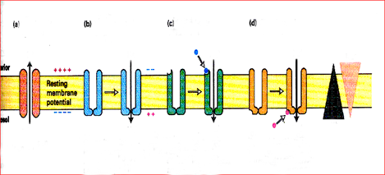
(f)
(e)
(a)______________________________________________
(b)______________________________________________
(c)______________________________________________
(d)______________________________________________
Write an example for (e), which can trigger Na⁺ flow into the cell, and the name of the receptor it binds to: __________________

List ionotropic receptors which can (or able to) bind glutamate and the ion(s) to which they are permeable. 4 points
Type Ion(s)
_____________________ _______________________
_____________________ _______________________

List two possible causes of neural tissue damage. 1 point
________________________________________________________________________

Steps of signal transduction. Numbers next to a symbol mark a particular class of the cascade. Pair each of the listed members of different signalling pathways with the correct number(s)! (9 point)
GABA_{A} receptors: _________

Ca²⁺ : ___________________

Dopamine: ______________

GABA_{B} receptors: _________

G proterin: _______________

Second messengers: ________

NMDA receptors: ___________

cAMP: ____________________

metabotropic GLUT receptors:

______

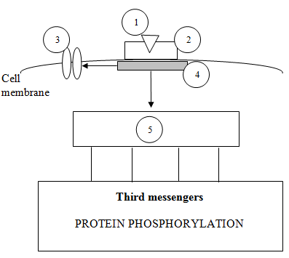

What processes can be observed in the perikaryon of a neuron after transecting its axon? (list 2) 1 point

