Identify the structures numbered in the electron microscopic picture, and answer the question. 5 points

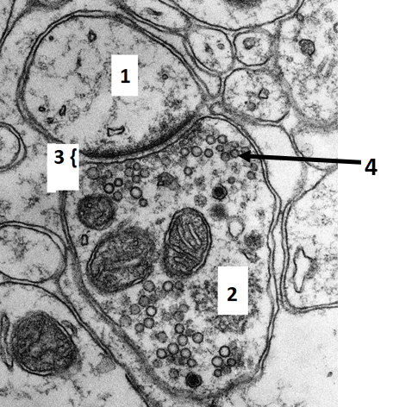
1 ____________________
2 ____________________
3 ____________________
4 ____________________

What type of synaptic specialization is it? _________________________

Complete the text about the neuroglia with the correct words or phrases. 5 points
Most neuroglia cells develop from ___________________ in the brain, except the ___________________, that derive from the bone marrow. This latter type of neuroglia and astrocytes together form a powerful _________________ system in the CNS. The processes of astrocytes project to blood vessels to form the ____________________. Astrocytes are able to generate spreading calcium waves, because they are coupled by _______________________.

Answer the questions below related to the connection and the measured potential changes, shown in the figures! 5 points
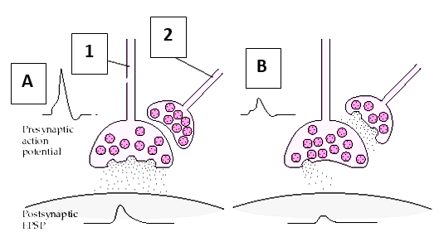
What kind of process is number 1 according to its function? __________________________________
What kind of process is number 2 according to its function? __________________________________
Which neurotransmitter could be released from process number 1? __________________________________
What change can be observed in the charge distribution within the process number 1 in the case of B compared to the case A?
_____________________________________________________________
What is the shape of the vesicles generally carried by process number 2? ________________________________
Complete the text about the neuroglia with the correct words or phrases. 5 points
Neurons communicate with non-neuronal elements via nerve endings, that can be classified into two main categories: _______________ and _____________. One of these categories includes the motor endplates, whose axons innervates the _______________________, and use _____________ as neurotransmitter. An example for the other category of nerve endings can be ________________.

