Name the numbered structures. 5points

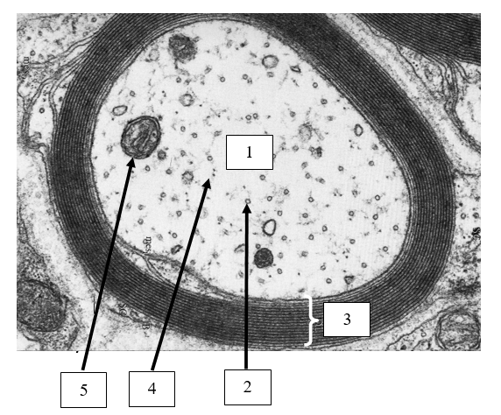

1 _______________________
2 _______________________
3 _______________________
4 _______________________
5 _______________________

Answer the following questions. 5 points

What cell types are responsible for generating structure 3 (marked in the previous exercise) in the CNS and in the PNS, respectively.

What is the function of the axon hillock?

Define bipolar neurons.

List the 3 main types of inhibition.

What causes repolarization at the end of AP generation?

Identify the organelles of the cell numbered in the scheme. 5points

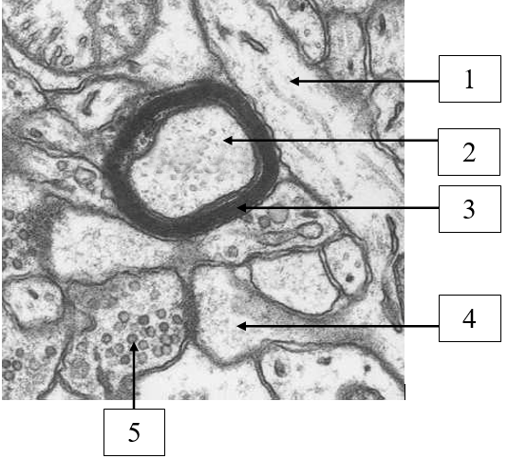
1 ______________________
2 ______________________
3 ______________________
4 ______________________
5 ______________________

Answer the following questions. 5 points

What is the function of structure 3 (marked in the previous exercise)?

What ensures the maintenance of resting potential (-70 mV) in neurons?

Define Ranvier node.

Define the neuropil part of the nervous tissue!

What causes depolarization in AP generation?

