Identify the organelles of the cell numbered in the scheme. 2.5points

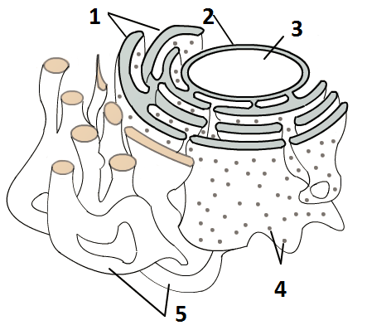

1 ___________________________
2 ___________________________
3 ___________________________
4 ___________________________
5 ___________________________

Decide whether the following statements are true or false. Explain your answer. 2.5 + 5 points

Cells are capable of structural plasticity. _____________
__________________________________________________________________________
Facilitated diffusion requires energy (ATP). _____________
__________________________________________________________________________
Nucleoli are mainly present in cells that are under intense protein synthesis. ____________
___________________________________________________________________________
RER takes part in lipid synthesis. ______________
___________________________________________________________________________
Golgi hydrolase vesicles fuse with endosomes to make it possible to digest enzymes. ___
__________________________________________________________________________

Identify the organelles of the cell numbered in the scheme. 2.5points

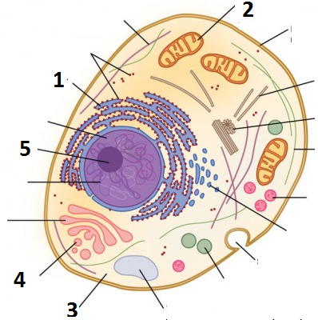
1 _________________________
2 _________________________
3 _________________________
4 _________________________
5 _________________________

Decide whether the following statements are true or false. Explain your answer. 2.5 + 5 points

The resolution of light microscopy is sufficient to investigate most of the subcellular organelles in the human body. ____
_________________________________________________________________
Active transport operates along concentration gradients. ____
_________________________________________________________________
Macromolecules cannot traffic between the nucleus and the cytoplasm because the nucleoplasm is surrounded by a double membrane. ____
_________________________________________________________________
Ribosomes are attached to the outer surface of the SER. ____
_________________________________________________________________
SER is abundant in liver cells. ____
_________________________________________________________________

