Name the numbered cell types or afferents of the cerebellar network! Separate the cortical layers by drawing lines and name the different layers next to the scheme! 7 points

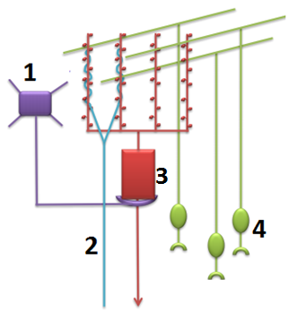
1. ___________________________
2. ___________________________
3. ___________________________
4. ___________________________

Open part of the medulla. Associate the corresponding number(s) with the statements below! (Multiple answers might be possible!) 3 points

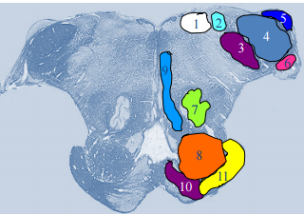

Vestibular information is processed here: _________________________
It conveys the fibers of the pyramidal tract: _______________________
Associated with the cochlear system: _____________________________
Synaptic specializations in the cerebellar cortex. Identify the type of synapses (A,B) and the components (contributing neuronal processes). 7 points
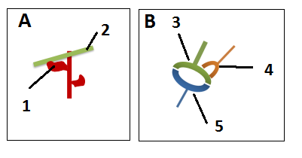
A: _________________________________
1: _________________________________
2: _________________________________
B: _________________________________
3: _________________________________
4: _________________________________
5: _________________________________
Mesencephalon at the level of superior colliculi. Associate the corresponding number(s) with the statements below! 3 points
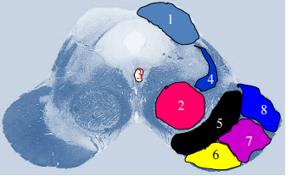

Major dopamine synthesising nucleus: _______________________
Conveys motor commands to lower motoneurons: ___________________
A “relay station” of the visual pathway: ________________________

