BASICS OF NEUROBIOLOGY
Zsolt Liposits and Imre Kalló
2016-2017

9. BRAIN STEM
STRUCTURE OF CEREBELLUM
NETWORKING OF CEREBELLUM

Brief summary:
The first lecture gives a detailed description of the brain stem including the surface structures, the major constituents, its cavity, the cranial nerves originating from and the supplying vessels. The second and the third lectures describe the location and major parts of the cerebellum; parcellation is explained on the bases of philogenetic development and functional connections with the spinal cord and other brain regions. The cerebellar cell types, their afferent and efferent connections are also explained.

One has gained sufficient knowledge, if understands and can explain the followings:
- The brain stem has three parts, which develop from the midbrain and the hindbrain (rhombencephalon).
- The brain stem hosts 10 out of 12 cranial nerves, which ensure all functions for the neck and the face, as spinal neurons do for the body and the limbs.
- The brain stem level is the site, where CSF moves in and out of the 4th ventricle and the subarachnoidal space.
- The cerebellum establish connection with all three parts of the brain stem, through which it can gain essential somatosensory, vestibular and higher cortical informations to carry out its motor control.
- The different cell types, and the functional interconnections in the cerebellar cortex.

Test the knowledge you gained:

- Make a schematic drawing of the neuronal circuits of the cerebellum. Depict the following structures and their specific connections. 10 points
1. Purkinje cell. 2. Granule cell. 3. Golgi cell. 4. Basket cell. 5. Dentate nucleus 6. Climbing fiber. 7. Mossy fiber. 8. Glomerulus. 9. Parallel fiber. 10. Termination site of the Purkinje axon.

- List the number of cranial nerves characterised by the following sentences! 5 points

- It has purely sensory functions: _________________________
- It has purely motor functions: _________________________
- It has autonomic motor functions: _________________________
- It participates in the eye(ball) movements: __________________________
- They share the same somatomotor nucleus in the brain stem: __________________________

- This figure shows the coronal section of the midbrain at the level of the superior colliculus. Associate the statements with the corresponding brain stem structure! 5 points
a. It conveys the fibers of the pyramidal tract: ______________________
b. It is a relay station of the visual pathway: ______________________
c. It is a somatosensory pathway: ______________________
d. It terminates in the pons: ______________________
e. It’s dopamine content is high: ______________________
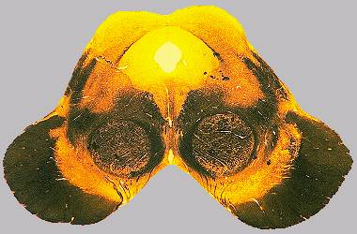
1
2
3
4
5
6

- This electron micrograph shows a climbing fiber (No 1).
Answer the following questions: 8 pont
Where is located the somatodendritic part of the neuron, which is giving rise to this process?___________________________
Which neuron’s process is No.2. ? _______________________________
What kind of processes (No. 3.) do surround No. 1. and 2.? ________________________________
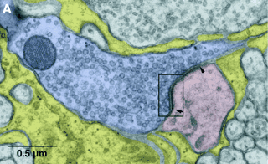
3
2
1
List three more functions of No.3. cells __________________________________________________________
__________________________________________________________________________________________
What kind of transmitter is stored in the synaptic vesicles of No1. process? ____________________________
What other cells contribute to the innervation of No2. process?______________________________________

- Identify the neurons characterised by the following statements! 4 points
The neurons from this nucleus can activate individual Purkinje cells selectively and very efficiently, even in an inhibited zone of the cerebellar cortex.
The name of the nucleus:_______________________________________________________________________
These neurons are capable to establish inhibited areas on both side of the activated Purkinje cells.
The name of the neurons: ______________________________________________________________________
These neurons collect information from the spinal cord, brainstem as well as the neocortex and can activate several Purkinje cells, but only with concurrent, additional inputs.
The name of the neurons: ________________________________________________________________________
These neurons establish a long pathway, which carries information from the periphery direct to the brainstem.
The name of the neurons: _______________________________________________________________

