BASICS OF NEUROBIOLOGY
Zsolt Liposits and Imre Kalló
2016-2017
8. TRACTS OF SPINAL CORD
STRETCH REFLEX
FLEXOR AND AUTONOMIC REFLEXES

Brief summary:
The first lecture explains the organization of the white matter of spinal cord and demonstrates the major ascending and descending pathways with the location of contributing neurons and the functions provided. The second and the third lectures introduce the term reflex arc, which is a multicellular pathway capable to trigger actions in response to internal or external stimuli. Five basic elements are described morphologically as well as functionally; the receptors (the sensor of the internal and external stimuli), the afferents (carrying the information to the center), the center (mono- or polysynaptic connections, which allow processing and distributing the incoming signal), the efferents (carrying the information from the center) and the effectors (the executive units – usually muscles or glands).

One has gained sufficient knowledge, if understands and can explain the followings:
- At some extent, the human body preserved the segmental organization of phylogenetically more ancient creatures. The segments became more or less reorganised, but kept their controlling neuronal pathways with sensory and motor innervation.
- The spinal cord collects sensory information from the body and the limbs. The information is conveyed to higher brain centers via ascending pathways.
- There are pathways selective for the different sensory modalities. Some sensory modalities are carried by paralell pathways to different brain centers.
- The spinal cord sends motor commands to the body and the limbs. The information is conveyed from higher brain centers via descending pathways.
- There are pathways, which carry motor information from different higher brain centers.
- Reflex arcs have five basic elements.
- The generation of specific responses to stretch, pain or visceral sensations.
- The consequences of spinal cord injury.

Test the knowledge you gained:
- List the major parts of the white matter and the grey matter (the area/volume occupied by the numbered pathways or cell groups marked by letters): (10 points)
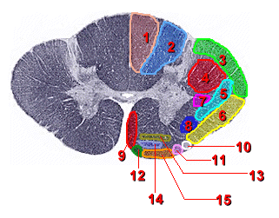
c
b
a
Major parts of the white matter:
1, 2_________________________________
____________________________________
3,4,5,6,7,8____________________________
____________________________________
9,10,11,12,13,14,15____________________
____________________________________
Major parts of the grey matter:
a _________________________ b___________________________ c______________________________
List the major parts of the spinal cord and the segments, which build up these parts!
_______________________________________________________________________________________
_______________________________________________________________________________________
_______________________________________________________________________________________
_____________________________________________________________________________________

- This is a spinal cord motoneuron. Write the letter of specific parts of this motoneuron into the corresponding squeres! (5 points)
It shows the phenomenon called „chromatolysis” after cutting the neuron at the marked area.

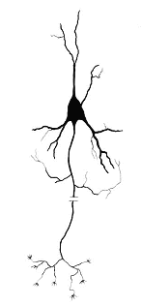
Acetylcholine is released at this site.
It inhibits other motoneurons.
It synapses with fibers deriving from the corticospinal tract.
It is part of the spinal nerve.

e
d
c
b
a
- Identify the parts of the spinal cord (white or grey matter), where the following structures are located:
4 points
a. Cell bodies of motoneurons of the autonomic nervous system: _____________________________________
b. Fasciculus gracilis: _____________________________________________
c. Crossed pyramidal tract: _____________________________________________
d. Substantia gelatinosa Rolandi: _____________________________________________

