BASICS OF NEUROBIOLOGY
Zsolt Liposits and Imre Kalló
2016-2017

7. DEVELOPMENT OF THE NERVOUS SYSTEM
SPINAL CORD
INTERNAL STRUCTURE OF SPINAL CORD

Brief summary:
The first lecture describes the major steps of nervous system development from the formation of neural plate till the cyto-differentiation of the cerebral cortex. The second lecture provides an overview about the structural organization of the spinal cord, and explains the term of spinal cord segments, which receives sensory input from and send motor commands to well defined portions (segments, the existence of which is not obvious in humans) of the human body. The third lecture demonstrates the location of spinal cord neurons, which send information to peripheral targets, form local connections or establish ascending pathways to send information to supraspinal centers. Descending pathways are also described, which bring information from supraspinal centers.

One has gained sufficient knowledge, if understands and can explain the followings:
- The development of the central nervous system from a tube-like structure, the wall of which host initially stem cells. After multiplication, cells differentiate into neurons and glial cells and establish function-related connections with the capacity of plastic changes.
- The basic structure of spinal cord is organised to support body segments. The term of reflex arch, and the difference between somatic and autonomic reflex arches.
- The arrangement of nerve fibers within the spinal cord carrying motor and/or sensory informations from and to supraspinal centers.

Test the knowledge you gained:

- Identify the selected numbered structures by using the schematic drawing of the spinal cord! Then, associate the statements with the corresponding numbers of the figure. Finally depict the locations of the Substantia gelatinosa Rolandi and the Tractus fundamentalis in the schematic drawing. (10 points)
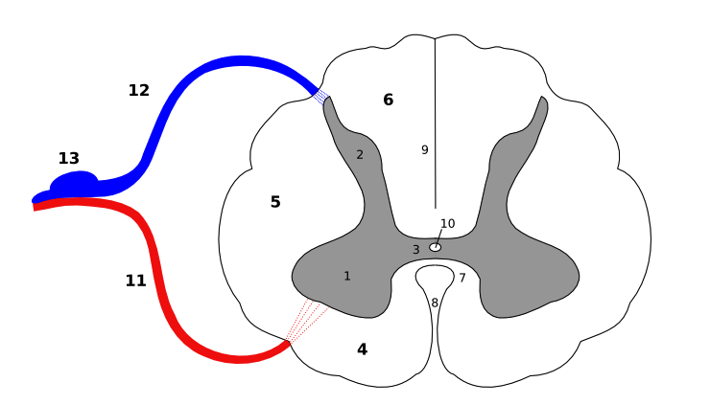

1______________________________________8._____________________________________________
9._____________________________________13.____________________________________________
In this structure fibers connect the right and the left halves of the spinal cord: _____________________
Both ascending and descending fibers can be found in this structure: _____________________________
The cell body of the sensory neurons is located here: _________________________________________
Cerebrospinal fluid can be found in this(ese) space(s): _________________________________________
- Give a short definition for the following terms! (10 points)
Reflex arch: _______________________________________________________________________________
_________________________________________________________________________________________
_________________________________________________________________________________________
Axon initial segment: _______________________________________________________________________
________________________________________________________________________________________
________________________________________________________________________________________
Ranvier nodes: ____________________________________________________________________________
_________________________________________________________________________________________
_________________________________________________________________________________________
Resting membrane potential: _________________________________________________________________
_________________________________________________________________________________________
_________________________________________________________________________________________
Second messenger: _________________________________________________________________________
_________________________________________________________________________________________
__________________________________________________________________________________________

- Associate the statements below with the corresponding numbers of the figure. (13 points)
6
1
2
3
4
5
7
8
8
7
5
4
3
2
1
2
1
7

4

3

Nerve fibers, which derive from the spinal ganglion _________________
Connective tissue, which encapsules the subarachnoidal space _________________
Nerve fibers, most of which terminate in the cuneate and gracile nuclei _________________
This structure contains somatomotor axons _________________
The crossed pyramidal tract runs in this compartment _________________
Nerve fibers, which project to the cerebellum, are found here _________________
It contains gamma-type motor fibers _________________
It contains the rubrospinal tract _________________
Perikarya of the somatomotor neurons are located here _________________
It contains fibers from the lateral vestibular fibers _________________
It participates in filtering pain _________________
This structure may convey autonomic, preganglionar fibers _________________
It conveys nerve fibers projecting to the thalamic VPL nucleus _________________

