BASICS OF NEUROBIOLOGY
Zsolt Liposits and Imre Kalló
2016-2017

4. NEUROGLIA
NERVE ENDINGS
SYNAPTIC COMMUNICATION

Brief summary:
The first lecture explains the phenotype and the functions of the different glial cells by emphasizing their essential role in maintaining a healthy nervous tissue and neuronal operation. The second lecture demonstrates the structural elements and molecular mechanisms of neurons, which serve to pick up (from receptors) and transmit (to other neurons and effectors) information. The third lecture summarises the structural and molecular bases of interneuronal communications, which ensure high specificity, controllability, feed-back and plasticity.

One has gained sufficient knowledge, if understand and can explain the followings:
1) The way, how different glial cells contribute to the maintenance of neuronal functions.
2) The way, how various physical and chemical changes in our close environment are detected and transformed to sensory information.
3) The structural elements and the mechanisms, which are involved in the transformation of neuronal activity to muscle contraction or secretion.
4) The structure and the operation of chemical synapses.
5) The structure and the operation of electric synapses.

Test the knowledge you gained:

- List the different types of glial cells and characterize them by their major function! (10 points)
a. ................................................. .....................................................................................
b. ................................................. .....................................................................................
c. ................................................. ....................................................................................
d. ................................................. .....................................................................................
e. ................................................. .....................................................................................
- Supplement the text below with the missing words! (12 points)
The level of exchange of various molecules (nutrients, metabolites, small molecules etc) between the blood and brain is determined by the ________________________________. Damage of this protective system, e.g. by ______________________________, results in a(n) ____________________________ of the fluid in the extracellular space first around the vessels, which in turn leads disturbance in neuronal functions. This protective system is composed of three cellular and one non-cellular component. The cellular components are the ____________________ cells, the _______________________ cells and __________________________. The non-cellular element is the _______________________. The inner layer of the vessels is formed by the _________________________ cells, which are connected to each other by _______________________________; this connection type cannot be observed in the peripheral vessels. The vessels are covered by the processes of ___________________________________. These cells have two major types: a ____________________________________ and the _______________________________________. The first type is primarily located in the white matter, whereas the second type of the cells occupies the gray matter.
- This figure shows schematically how neurotransmitters are eliminated from the synaptic cleft. Identify the different physiological processes! (10 points)
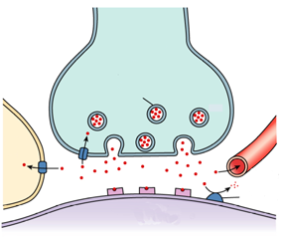
1. ________________________________________

2. ________________________________________

3. ________________________________________

4. ________________________________________

5. ________________________________________

5
4
3
2
1
- Answer the questions below related to the connection and the measured potential changes, shown in the figures! (10 points)
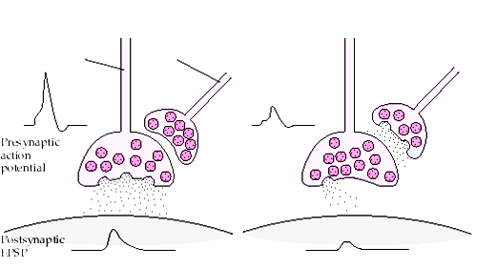
B
1
2
A
What kind of process number 1 according to its function? ______________________________________________
What kind of process number 2 according to its function? ______________________________________________
Which neurotransmitter could be released from process number 1_______________________________________?
What change can be observed in the charge distribution within the process number 1 in the case of B compared to the case A? ____________________________________________________________________________________
What type of ion channels could be found in the process number one? ____________________________________

