BASICS OF NEUROBIOLOGY
Zsolt Liposits and Imre Kalló
2016-2017

3. NERVOUS TISSUE
THE NEURON
NERVE FIBERS

Brief summary:
The first lecture characterises the nervous tissue, in which neurons and glial cells exist in structural and functional symbioses. The second lecture demonstrates the unique morphology and the excitability of neurons and some basic networks established by them. The third lecture explains how information is conveyed via nerve fibers between distant locations in the human body.

One has gained sufficient knowledge, if understand and can explain the followings:
1) The structural and functional symbioses of neurons and glial cells.
2) The morphological and functional diversity of neurons. Mutual definiteness of morphology and function.
3) Resting potential and action potential.
4) Electrotonic potential, conductance.
5) The role of somatodendritic region in information processing.
6) The structure of neuropil and events, which take place in the neuropil.

Test the knowledge you gained:
- These schematic drawings demonstrate electrotonic changes in response to stimuli. There are three electrodes in the cell, each of those measure potential changes in response to the stimulus. Evaluate the following sentences for correctness! (5 points)
The stimulus evoked electrotonic potential is weakened towards the axon initial segment in both A and B cases. _______________
In the case of B, the electrotonic potential is higher than the threshold potential next to the axon initial segment. _______________
In the case of A, the electrotonic potential can induce action potentials, if it is summed with another electronic potential deriving from another synaptic stimulus.
_______________
Action potential is generated if the electrotonic potential
reaches the axon initial segment.
_______________
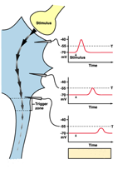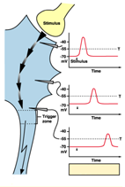
B
A

In the case of A, the cell is hyperpolarized, in the case of B, the cell is depolarized. ___________________

- Nerve fibers. Supplement the text with the missing words. (8 points)
The filament-like structure composed of the _________________________ and the _______________________ is called a nerve fiber. The ____________________________ is part of the neuron; the larger its diameter, the __________________________________ is its conductance speed. The ___________________________ is produced by glial cells. The glial cells with this function in the peripheral nervous system are called ____________________________, whereas the name of the cells with similar function in the central nervous system is ________________________________. The glial cells in the peripheral nervous system are capable to embed several neuronal processes (named above). The latter type of nerve fibers is called ___________________________________.
- Evaluate the following sentences for correctness! If you think that the statement is true, give the name of the labeled structure. If you think, that the statement is false, then provide a brief explanation why! (10 points)
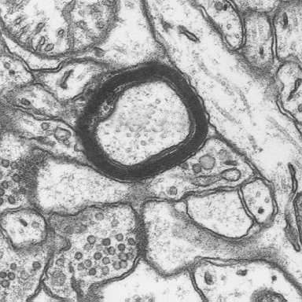
4
2
3
1
5

1. This is an axon, because it is thin and establishes branches. ____________
Name/Why?_________________________________________________________________________________
2. This is a 25 nm-thick tube, which has transport functions. ____________
Name/Why?_________________________________________________________________________________
3. Membrane of glial cells, which envelopes structure 2 in multiple layers. ____________
Name/Why?_________________________________________________________________________________
4. This is a glial cell, the nucleus of which is not in the plane of the section. _____________
Name/Why?_________________________________________________________________________________
5. In response to action potential, some of the vesicles inside open up and release transmitters
into the synaptic cleft. ______________
Name/Why?_________________________________________________________________________________

- Identify the numbered structures! 5 points
1.
1.
5.
1.
4.
1.
3.
1.
2.
1.

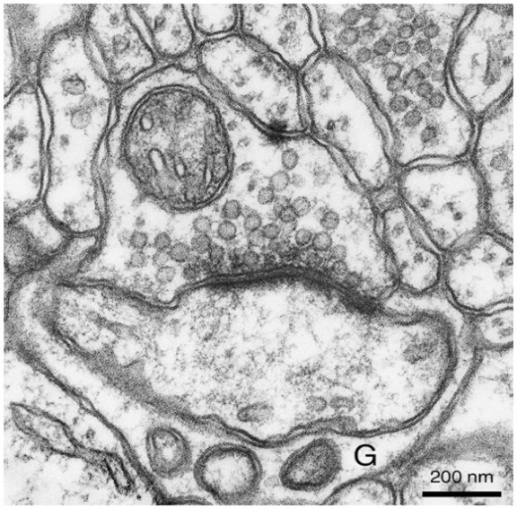
1. …………………………………………………………………………
2. ………………………………………………………………………..
3. ……………………………………………………………………….
4. ………………………………………………………………………..
5. ………………………………………………………………………..

1.

