BASICS OF NEUROBIOLOGY
Zsolt Liposits and Imre Kalló
2016-2017
2. THE CELL
CELL ORGANELLES I.
CELL ORGANELLES II.

Brief summary:
The first lecture demonstrates cells of the human body, specialised to carry out certain functions. Specialization of the cells means to operate different sets of genes besides those used constitutively in all cell types.
The second and the third lectures provide a brief review of cellular organelles operating in all somatic cell types, including the neurons and glial cells.

One has gained sufficient knowledge, if understand and can explain the followings:
1) The way the cells can specialize to carry out different functions (gain different morphology and chemotype).
2) The basic structure and function of cellular organelles.
3) The basic process of protein synthesis and modifications.
4) The way of energy production to serve cellular events.

Test the knowledge you gained:
- Electron microscopic image of a somatic cell. Identify the numbered structures! 5 points
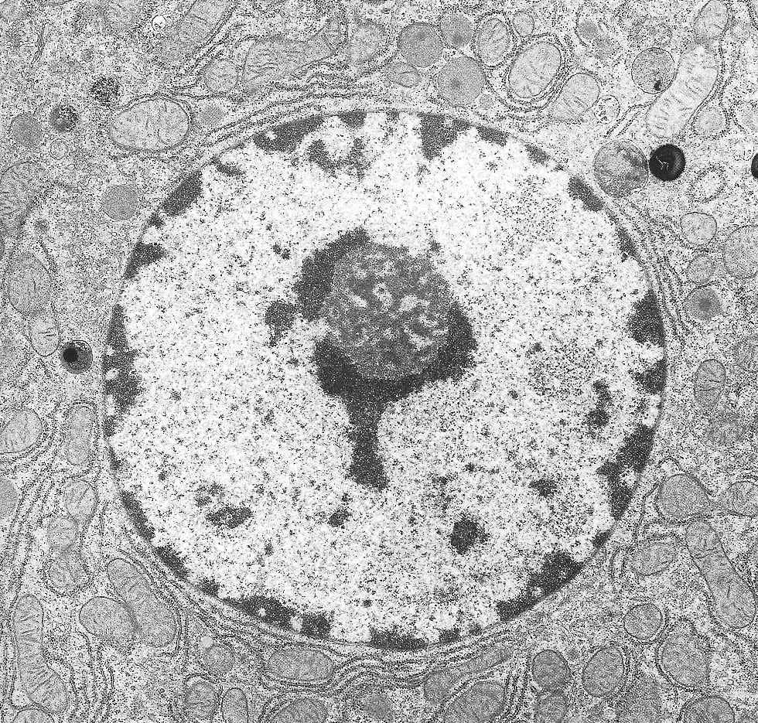
5
4
3
2
1

- Identify the cell organelle characterised by the following sentences:

A fiber-like structure with an average of 10 nm diameter, that contributes to the maintenance of the cell’s shape: __________________________________
Ion channels belong to this category of membrane proteins: _________________________________
The location of ribosomal RNA synthesis: __________________________________
The location of ATP synthesis: __________________________________
The location of degradation of cellular organelles: __________________________________
- Identify the organelles labelled with numbers and the cellular events labelled with letters!
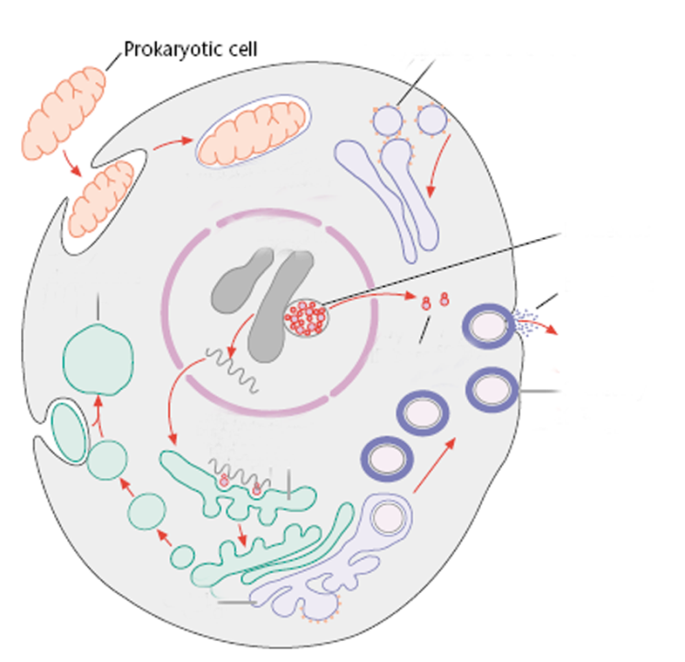
- ________________________________
- ________________________________
- ________________________________
- ________________________________
- ________________________________
- ________________________________
- ________________________________
- ________________________________
- ________________________________
1
2
4
5
6
7
8
9
a
b
c
d
e
f
g
h
i
j
3

- ___________________________________________________________________________
- ___________________________________________________________________________
- ___________________________________________________________________________
- ___________________________________________________________________________
- ___________________________________________________________________________
- ___________________________________________________________________________
- ___________________________________________________________________________
- ___________________________________________________________________________
- ___________________________________________________________________________
- ___________________________________________________________________________

