BASICS OF NEUROBIOLOGY
Zsolt Liposits and Imre Kalló
2016-2017

10. ORGANIZATION OF THE BRAIN STEM
NETWORKING OF BRAIN STEM
CRANIAL NERVES

Brief summary:
The first lecture demonstrates the brain stem’s major constituents i.e. the neuronal clusters, the ascending and descending pathways, decussations and the origin of cranial nerves at different rostro-caudal levels. The neuronal clusters either appear as nuclei or interconnected cells forming a reticulum i.e. reticular formation.
The second lecture demonstrates the ascending and descending pathways, which either terminate in the brain stem or path through it at a relayed manner or without being relayed. The third lecture explains the functional constituents and the location of the different cranial nerves.

One has gained sufficient knowledge, if understands and can explain the followings:
- The brain stem has inherent regulatory functions i.e. it controls somatic (e.g. coordinated eye movements) and vital autonomic functions (e.g. respiration, circulation, feeding, state of consciousness, arousal)
- The brain stem transmits motor and sensory pathways.
- There are motor cranial nerves carrying out either single (somatic) or multiple motor (somato and autonomic) functions.
- There are sensory cranial nerves carrying out either single, or multiple sensory (somatic and autonomic) functions.

Test the knowledge you gained:

- Scheme of a horizontal slice of the left hemisphere! Identify the numbered structures (write the name of the structure next to the number) and answer the related questions! 10 points
1
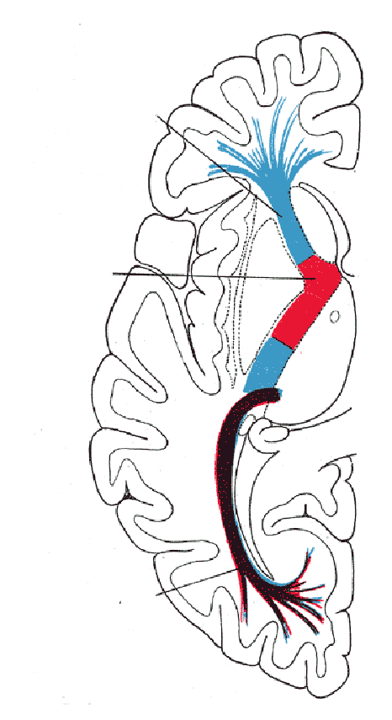
7
3
2
6
4
5
Structural component of the corpus striatum: _________________________________
It contains descending pathways from the cerebral cortex: _________________________________
It provides a stimulatory input of the cerebral cortex: _________________________________
- Identify the names of the numbered structures! 10 points
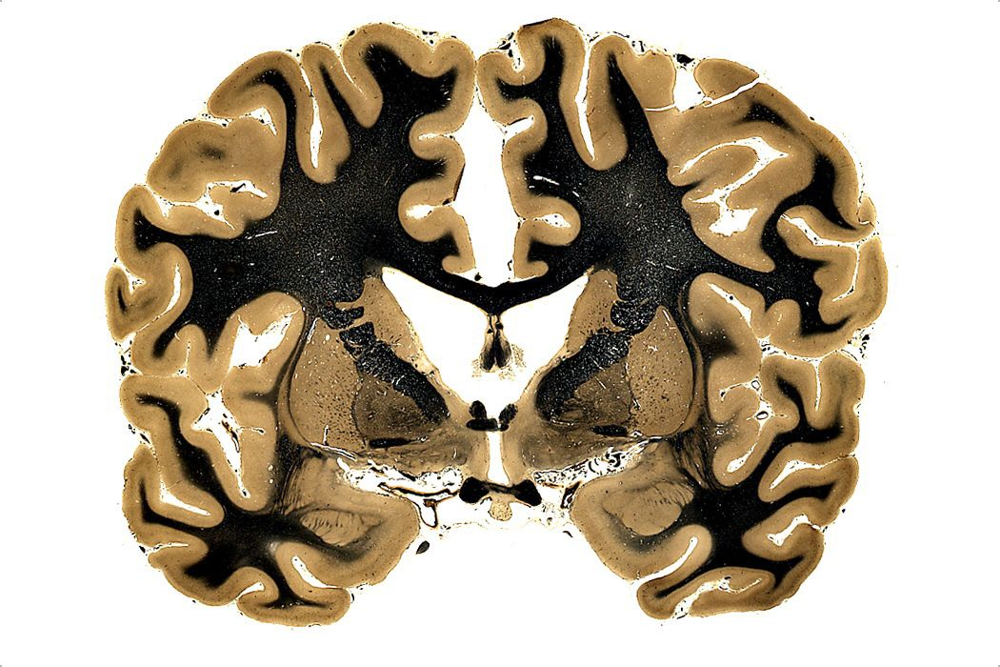
1.

2.

3.

4.

5.

6.

7.

8.

9.

10.
8
6
4
5
2
7
10
1
9
3

