13. Semi-classical Perturbation of the Interaction of Matter with Light
a. Time-independent Perturbation of Matter by Classical Radiation. Perturbation of the eigen-energies and the orbitals. Changing the spectrum of matter.
diákból:
If we solve the Schrödinger equation for the static Hamiltonian representing the strong effect of the nuclei we get the set of eigenenergies and eigen-kets forming a complete orthonormal set, thus every state can be expressed as a linear combination of the eigenstates. If the external field acting on the system are “weak” compared to the effect of the nuclei skeleton, then the external field can be considered just as a “perturbation”. There are cases when the perturbing field can be considered timeindependent, and there are cases when it is time-dependent.

Time-independent perturbation theory of the single-electron problem can give simple analytic formulae and values of coefficients for a new complete orthogonal set, useful in solving many problems (multi-electron, time-dependent perturbation, etc. It is conceptually useful in understanding interactions in general. Even if we are not performing an actual perturbation theory calculation, we can use perturbation theory to judge whether or not to include some energy in a finite basis subset calculation. If a given level is far away in energy and/or has a matrix element small compared to some closer level, we can safely neglect that given level because of the energy separations that would appear in the denominators in the perturbation terms. For small perturbations the perturbed kets are appr. normalized. However, it is straightforward to normalize them it needed.
Perturbation calculations are most useful for the first order of correction which is non-zero. First order perturbation Linear optics Second order perturbation Second harmonic generation Electro-optic effects Optical parametric amplifiers Third order perturbation Nonlinear refraction Four-wave mixing Perturbation theory is a theory of successive approximations. As can be seen, we use the zeroth order wavefunction to calculate the first-order energy correction, and we use the first-order energy correction in calculating the second-order wavefunction correction. This process continues.

Time-independent Perturbation Theory - Overview
Nondegenrate Case:
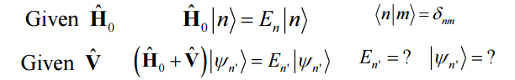
First-order Perturbation
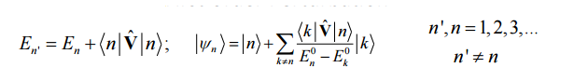
Second-order Perturbation
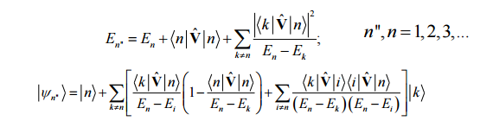
Degenerate Cases In “degenerate” cases there is more than one eigenket associated with a given eigenvalue. Often perturbations, e.g an electric field, will remove the degeneracy, making some of the states have different energies, and defining the distinct eigenfunctions uniquely.
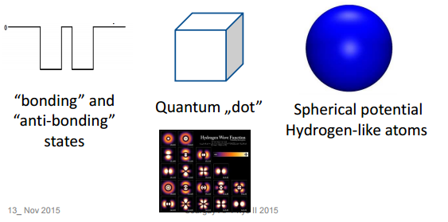
Suppose that there are r degenerate orthonormal eigen-functions
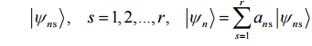
First order poerturbation equation
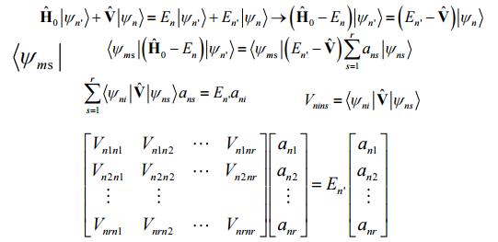
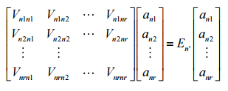
This is just a matrix eigen-equation. It generally has eigenvectors and eigenvalues. This degenerate perturbation calculation has therefore reduced to a special case of the finite basis subset model (or finite matrix model). In this case, the finite basis we choose is the set of r degenerate eigen-functions corresponding to a particular unperturbed energy eigenvalue E n The solution of the equation will give a set of r first-order corrections to the energy. Each associated with a particular new eigenvector that is a linear combination of the degenerate basis functions. All of these new eigenvectors are orthogonal to one another. To the extent that the energies are different from one another, the perturbation has “lifted the degeneracy”.

MEMO-ból:
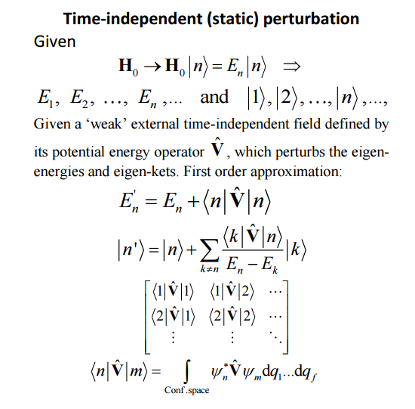
itt még vannak okosságok mind2höz: http://fizweb.elte.hu/download/Fizika-BSc/!BSc-Zarovizsga/kidolgozas_2009_tetelwiki/Atom-es-molekulaszerkezet.pdf

b. Time-dependent Perturbation of Matter by Classical Time-varying Electromagnetic Radiation.
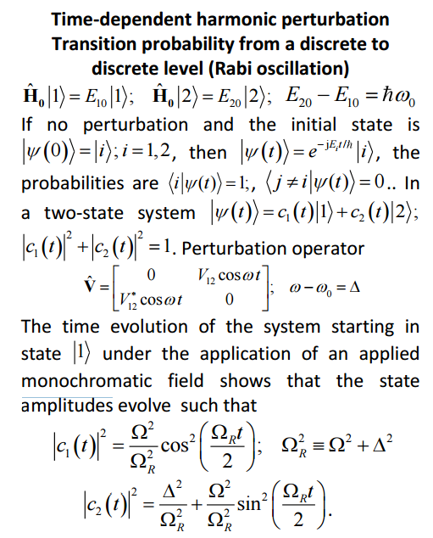
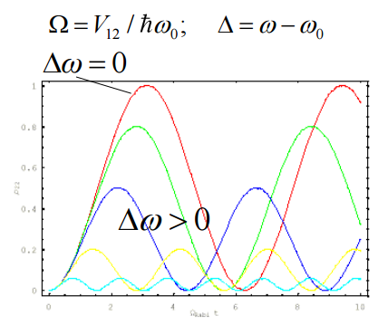

c. Electron transition between discrete energy eigen-states. Harmonic close-to-resonant time dependence leading to Rabi oscillation
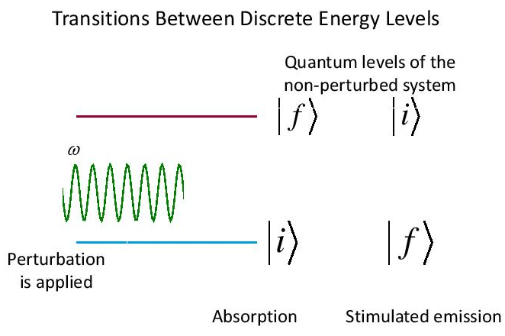
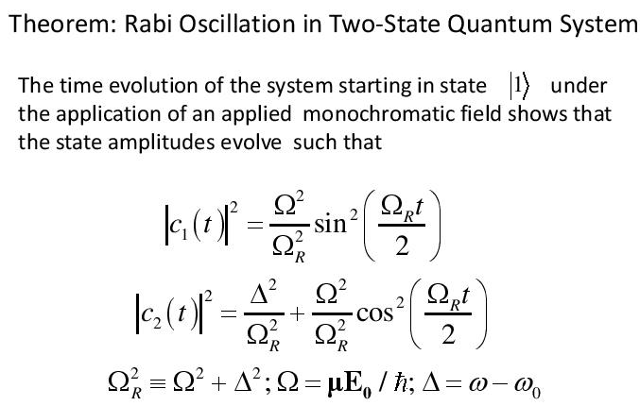
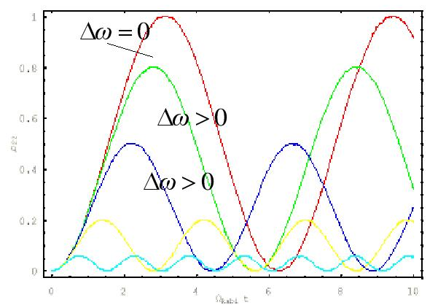
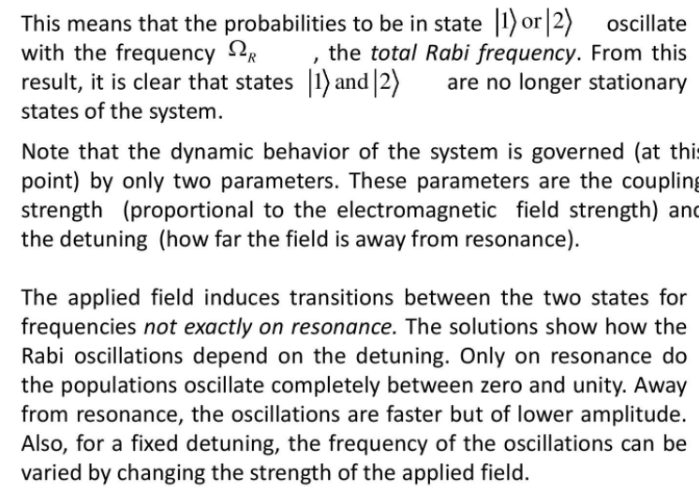
Mi az oszcilláció?
Az oszcilláció (oszcillálás) időben ismétlődő változás valamely stabil állapot(ok) körül.
d. Transition from a discrete eigen-state to an energy band by harmonic perturbation. Probability of transition: Fermi’s Golden Rule.
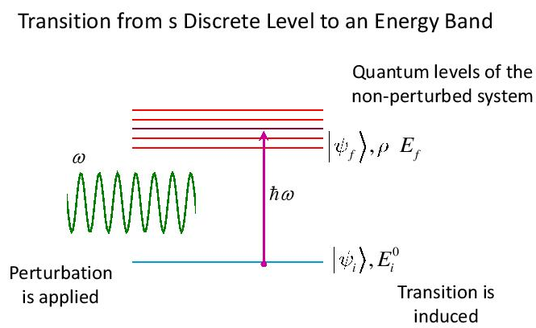
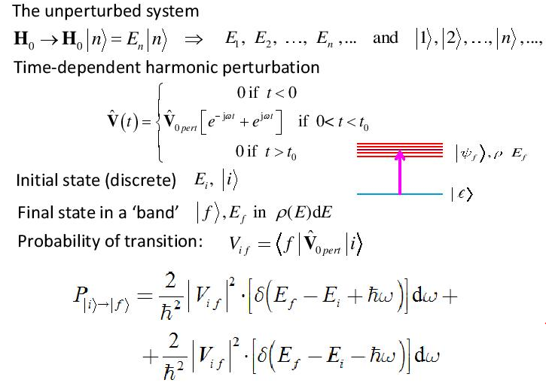
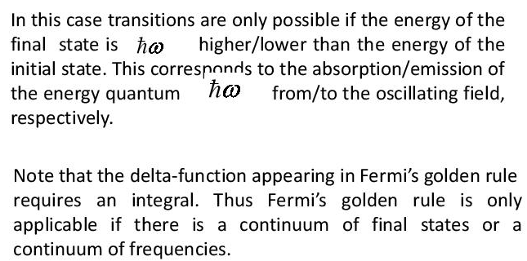

initial state: |i> is a discrete level with energy Ei
transition to a final state |f> of energy Ef in a band with leveldnsity rho Ef
Fermi’s golden rule:
Az elektron elemi részecske, mozgását tehát a kvantummechanika törvényei segítségével lehet leírni. A kvantummechanika „Fermi-féle aranyszabálya”(Fermi’s golden rule) elnevezéssel illetik azt az egyenletet, amely megadja annak valószínûségét
(λi-->f ), hogy egy elektron egy i állapotból átjuthasson egy f állapotba:
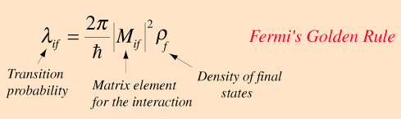

M_if az i és a f állapot közötti átmenetet leíró Hamilton-mátrix (ami a két elektronállapot közöttielektronikus csatoltság mértékét jellemzi), és ρ az f állapothoz tartozó állapotsûrûség, amely megadja egy bizonyos energiaintervallumon belüli alállapotok számát és elrendezôdését. Minél nagyobb az elektront leíró i és f állapotokhoz tartózó hullámfüggvények„átfedése” (azaz minél szorosabb az elektronikus csa-
toltság), annál nagyobb |M_if^2|– és így természetesen λi-->f értéke is. Továbbá, minél számosabb a f állapothoz tartozó alállapotok száma, annál valószínûbb az elektronátmenet.
Végső konklúzióm az internet segítségével:
A Fermi-féle aranyszabály folytonos/kvázifolytonos spektrumban segít átmeneti valószínűségeket kiszámítani. ω kör-frekvenciájú periodikus perturbáció esetén az időegységre jutó átmeneti valószínűség:
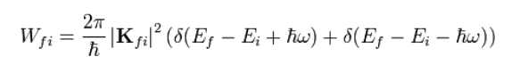
Itt a Wfi=Pif=λi-->f ---> FERMI’S GOLDEN RULE

