Interaction of Matter and the Electromagnetic Field (Matter-Light Interaction)
a. Classical and Quantum Model of Interacting Matter with the Electromagnetic Field. Semi classical and quantum-quantum model
One of the most important topics in time-dependent quantum mechanics for chemists is the description of spectroscopy, which refers to the study of matter through its interaction with light fields (electromagnetic radiation). Classically, light-matter interactions are a result of an oscillating electromagnetic field resonantly interacting with charged particles. Quantum mechanically, light fields will act to couple quantum states of the matter, as we have discussed earlier.
Like every other problem, our starting point is to derive a Hamiltonian for the light-matter interaction, which in the most general sense would be of the form
H=HM +HL +HLM . (4.1)
The Hamiltonian for the matter HM is generally (although not necessarily) time independent,
whereas the electromagnetic field HL and its interaction with the matter HLM are time-dependent.
A quantum mechanical treatment of the light would describe the light in terms of photons for different modes of electromagnetic radiation, which we will describe later.
We will start with a common semiclassical treatment of the problem. For this approach we treat the matter quantum mechanically, and treat the field classically. For the field we assume that the light only presents a time-dependent interaction potential that acts on the matter, but the matter doesn’t influence the light. (Quantum mechanical energy conservation says that we expect that the change in the matter to raise the quantum state of the system and annihilate a photon from the field. We won’t deal with this right now). We are just interested in the effect that the light has on the matter. In that case, we can really ignoreHL , and we have a Hamiltonian that can be solved in
the interaction picture representation:
H≈HM +HLM (t) =H0 +V(t)
Hamiltonian. It is obtained by starting with the force experienced by a charged particle in an electromagnetic field, developing a classical Hamiltonian for this system, and then substituting quantum operators for the matter:
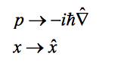

In order to get the classical Hamiltonian, we need to work through two steps: (1) We need to describe electromagnetic fields, specifically in terms of a vector potential, and (2) we need to describe how the electromagnetic field interacts with charged particles.

b. Many-electron model of a body: (i) Nuclear skeleton, (ii) Solution of the single- electron problem (energy spectrum; orbitals; Fermi statistics; electron population); (iii) Hamilton operator of matter

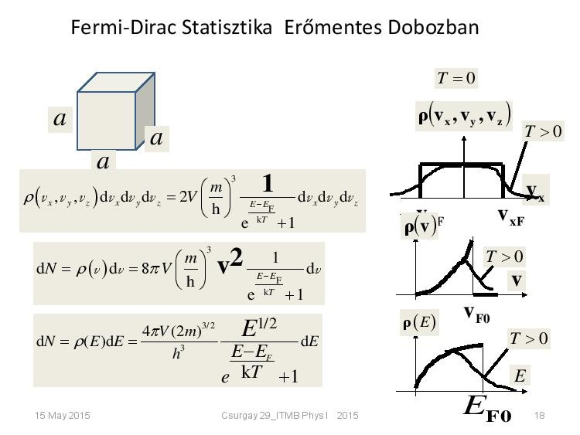
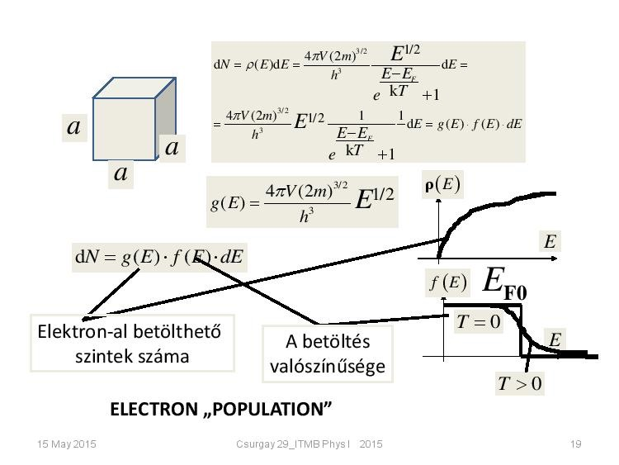

c. Many-photon model of the electromagnetic field: (i) classical cavity modes; (ii) quantization of cavity modes: photon number representation; (iii) Hamilton operator of radiation

Quantization of cavity modes: photon number representation: 1. tétel

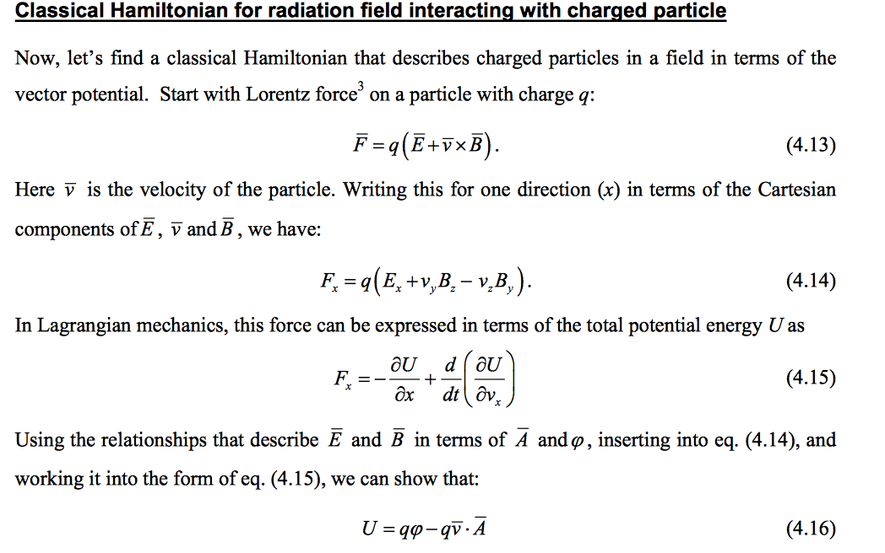
d. Hamilton operator of the interaction of matter and radiation

