9. Conductors, Insulators (Metals and Dielectrics)
a. The effective electron mass in solid-state matter. Single electron dynamics in solid state

b. The ‘Effective Mass Schrödinger Equation”
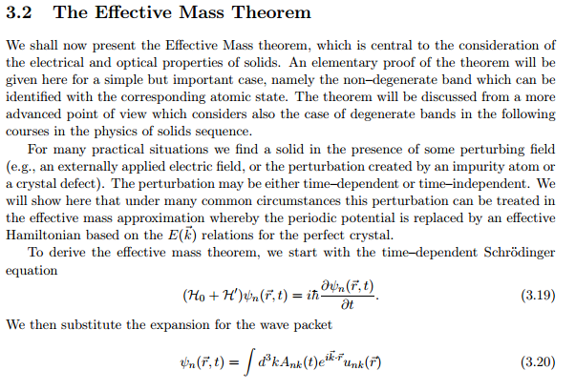
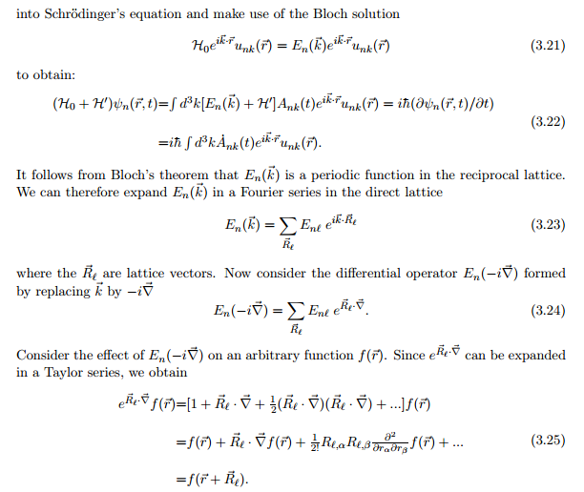
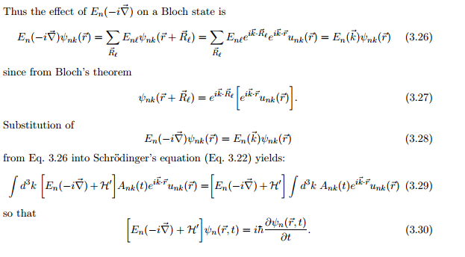
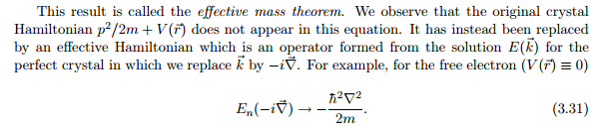

c. Occupation of the bands by electrons at T = 0 in conductors and insulators. The Fermi level of conductors .
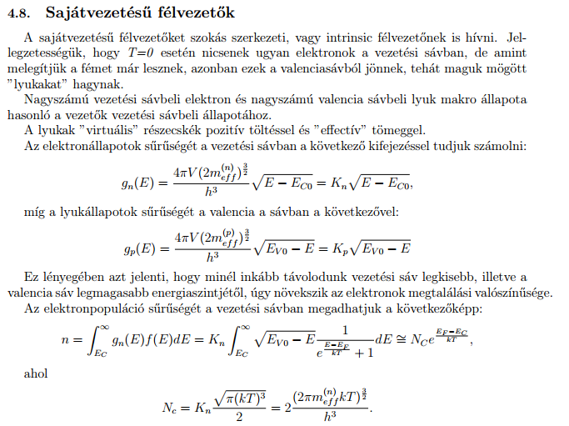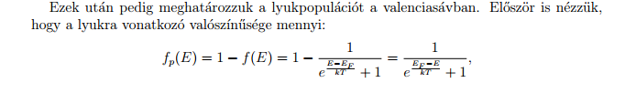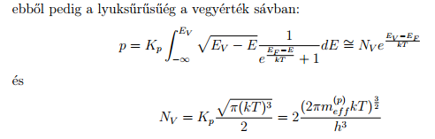
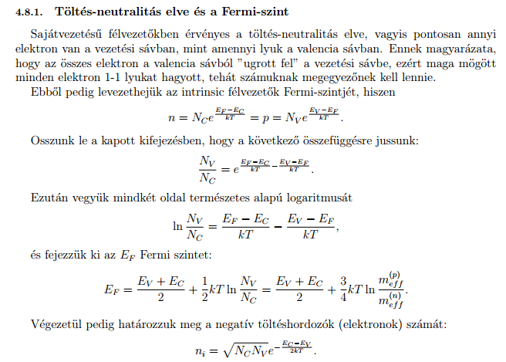

d. The Sommerfeld model of metals. The Richardson-Dushman theory of thermal electron emission, The contact potential at metal-metal junctions.
