Test 2014 6, 8, 16 nics kesz,tobbi megvan bar a 22ben nem vagyok meg biztos..
- Name the 4 core data types in bioinformatics!(4)
  - sequence
  - 3D
  - networks
  - text

- What is the structure and function in system? Give a definition of both of them!(4)
  - Structure and function are concepts of systems theory
  - Structure is a (~constant space-time) arrangement of elements or properties.
  - Function is a role played within a system

- Fill in the missing elements! (4)

Models | Entities | Relationships
Molecules | Atoms | Atomic interactions(chemical bonds)
Pathways | Enzymes | Chemical reactions(substrates/products)
Genetic networks | Genes | Co-regulation
Protein structure | Atoms | Chemical Bonds
Protein sequence | Amino acid | Sequential vicinity

- Define the Levenshtein edit-distance! (2)
- Edit distance between character strings (sequence), also called Levenshtein distance
- Defined as a sum of costs assigned to matches, replacements and gaps (=insertions and deletions). The two strings do not need to be of the same length.

What is the Levensthein edit-distance of the following sequences: x=CATACCTA, y=ACATTACC? Write down each step of our computation! (2)
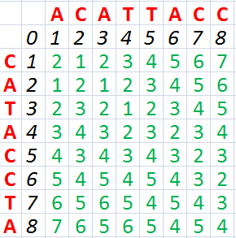

4, ha megegyezik akkor maximumot keresem felette és mellette -1, ha különbözik minimumot megkeresem felette és mellette +1

- Define the Jaccard coefficient that expresses the similarity of property sets A and B! (2)
- The Jaccard coefficient [0,1] expresses the similarity of two property sets a and b of non-zero attributes, respectively as
$$J = \frac{a ∩b}{a ∪b}$$
- J is 1 for identical and zero for completely different sets (or binary vectors).
Calculate the Jaccard coefficient, if:
A=[‘cat’, ‘dog’, ‘horse’, ‘duck’, ‘cow’, ‘chicken’]
B=[‘dog’, ’dolphin’ , ’duck’, ’dinosaurs’]! (2)
- $$a ∩b =$$ [‘dog’, ‘duck’] = 2
- $$a ∪b =$$ [‘cat’, ‘dog’, ‘horse’, ‘duck’, ‘cow’, ‘chicken’, ‘dolphin’, ‘dinosaurs’] = 8
- $$J = \frac{a ∩b}{a ∪b}= \frac{2}{8}= \frac{1}{4}=0,25$$

- Draw the schematic sequence X based on the following dotplot: (3)
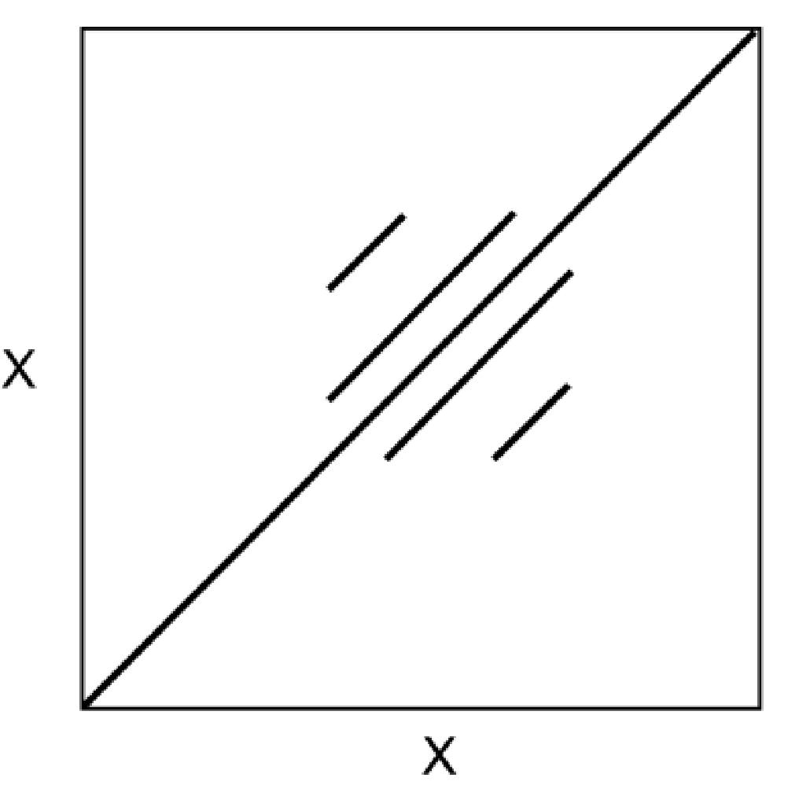 ????
- Calculate the log odds ratio of residues SERINE (S) and THREONINE (T) using the follow multiple alignment! (4)
T V S R A G
S T S V E T
T G T S K A
T K T N R H
- $$M(S⋰T)= log (\frac{f(S⋰T)}{F(S)×f(T)})$$
- $$f(S⋰T)=$$3
- $$F(S)=$$4, $$F(T)=7$$
- $$M(S⋰T)=log (\frac{3}{4*7}) = -0,97$$

- Fill in the missing words! (10)
Informally, an algorithm is any well-defined computational procedure that takes some value or a set of values as the input and produces some value or a set of values as output. An algorithm is thus a sequence of computational steps that transform the input into the output. It is important to predict the resources that the algorithm requires for a given input size. The resources are computational time and memory requirements. It is based on a simple ideal model machine: instructions are executed one after another, with no concurrent operations (RAM model), thus this measure is machine independent. The running time is defined as the number of steps to be carried out. It is assumed that the instructions are executed one after another, with no concurrent operations (RAM model). Memory requirement is the number of items (numbers, strings etc.) that one needs to store during the calculations. It is measured in terms of megabytes of disk space or RAM space. Furthermore there is a trade off between storage space and running time.
The worst case analysis is when one assumes inputs that lead to the upper limit of the resources. Average case analysis is when one uses an average input (problem-dependent, not trivial). In biocomputing this is the “idealized average” database, average (random) sequence of given length, etc.
In biocomputing, we mostly deal with sequences and databases as special kinds of input, both represented as character strings. The input size is often defined as the number of amino acids or nucleotides, described as the number of characters in a string. Another important parameter is the alphabet and database size. The alphabet size for proteins is 20, and for DNA it is 4.
The linear algorithms (O(l)) are the dream target. The O(l2), O(l3) may be used in practice, but not for all problems.
If the order is greater than Q(ln), i.e. it can not be expressed in a polynomial form, the problem is np-complete and intractable.
The Needleman-Wunsch and the Smith-Waterman algorithms solve similarity search problems and they have the time complexity O(I^2). The CLUSTALW2 algorithm has the time complexity n^2O(I^2) where the parameter n is the number of sequences and the parameter l is the length . This program is frequently used for computing multiple alignments.

- What is the meaning of p-value? What does it mean if it is close to 0? (3)
- Probability that an alignment with this score occurs by chance in a database of this size
- The closer the P-value is towards 0, the better the alignment

- Given the following e-value plot (generated after an hmmsearch) what would be your conclusion, which sequence would you consider belonging to the same protein family, how would you (if you would) further analyze the results?(5)
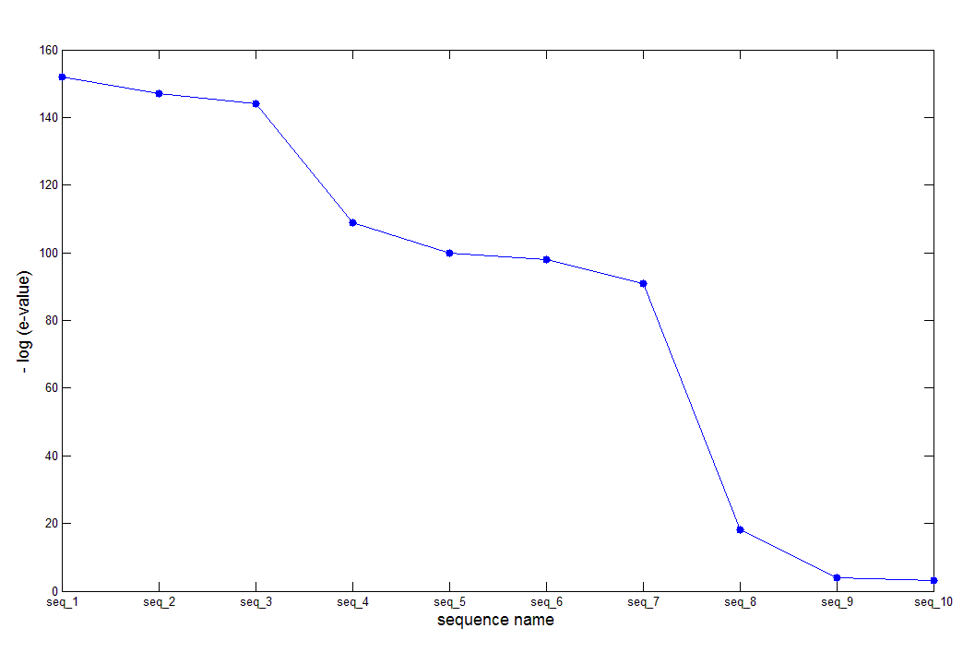
- e-value : number of matches with this score on can expect to find by chance in a database of N → metric for the significance of an alignment in a homology match
- e value: the closer the e-value is towards 0, the better the alignment
- egy család: [seq1,seq2,seq3]; [seq4-seq7]; [seq8-seq10]
- ugye minél közelebb van az e-value értéke, annál jobb, viszont a grafikonon az e-érték minusz logaritmusa van, tehát ha ez a -log(e-value) minél magasabb, annál jobb az alignment
- analizáslás?!

- Calculate the entropy of the following multiple alignment and draw the entropy plot! (6)
ATGC
ATCG
CTGA
CTCT

- lépés az oszlopokban lévő A, C, G, T valószínűségek felírása
  - első oszlop: P(A) = 0.5 , P(C)=0.5
  - második oszlop: P(T) = 1 (legjobb eset)
  - harmadik oszlop: P(C) = 0.5, P(G)=0.5
  - negyedik oszlop: P(A) = 0.25, P(C)=0.25, P(G) = 0.25, P(T)=0.25 (legrosszabb eset)

- lépésben kiszámítjuk az oszlopok entrópiáját:
- oszlopok : -[P(A) * log2 P(A)+P(C) * log2 P(C)+P(G) * log2 P(G)+P(T) * log2 P(T)]
  - első oszlop: -[0.5*log2(0.5) +0.5*log2(0.5)] = 1
  - második oszlop: -[1*log2(1)]= 0
  - harmadik oszlop: -[0.5*log2(0.5) +0.5*log2(0.5)] = 1
  - negyedik oszlop: -[0.25*log2(0.25) +0.25*log2(0.25)+0.25*log2(0.25) +0.25*log2(0.25)] = 2
- lépésben összeadjuk az oszlopok kiszámított értékét és megkapjuk a multiple alignment entrópiáját
  - 1+0+1+0+2=4

Entropy - plot
- x tengely - position
- y tengely - P(X) * logP(X)
- conserved regions show up as walleys
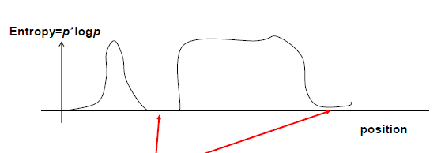

- Prepare the local alignment of the words ‘ACGC’ ad ‘GATTGA’ if we define the following point values:
gap penalty = -2, mismatch point = 0, match point = 2 ! (6)

- mivel local alignment, ezért Smith - Waterman algoritmust használunk
- 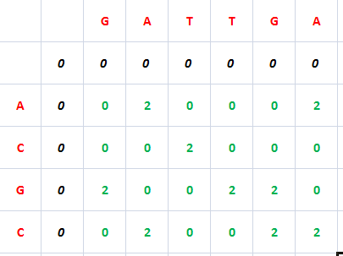
- szóval a lényege, hogy sehol nem lehet negatív értek, az oszlopba kerül az első szekvencia, sorba pedig a második szekvencia
- első sorban és oszlopban 0 értéket veszünk
- mellette és felette mindig a gap-ek vannak így -2 értéket kell venni az adott számból, az átlóba pedig megnézzünk hogy egyezés vagy nemegyezés van, ha egyezés akkor +2, ha nemegyezés akkor +0
- ezekután ha a kis négyzetben látjuk a kapott értékeket, tehát hogy mellette a gap utáni értéket, a felette lévő négyzetből kapott értéket és hogy match vagy mismatch van, ha negatív értékek vannak, akkor azok 0-k lesznek, mert NEM LEHET NEGATÍV ÉRTÉK A MÁTRIXBAN
- ha van pozitív érték, akkor a MAXIMUMOT választjuk ki
- ezek után ha van értelmes eredmény akkor leírjuk hogy milyen hasonlóság van, tehát a legnagyobb érték az első betűnk és utána bal sorokba felfele haladunk míg van pozitív értékünk, és ezek alapján tudjuk leírni a betűkombinációnkat is

- What is the difference between PAM and BLOSUM matrices? (4)

PAM | BLOSUM
First useful scoring matrix for protein | Much later entry to matrix “sweepstakes”
Assumed a Markov Model of evolution | No evolutionary model is assumed
 | Built from PROSITE derived sequence blocks
Derived from small, closely related proteins with ~15% divergence | Uses much larger, more diverse set of protein sequence (30%-90% ID)
Higher PAM numbers to detect more remote sequence similarities | Lower BLOSUM numbers to detect more remote sequence similarities
Lower PAM numbers to detect high similarities | Higher BLOSUM numbers to detect high similarities
1 PAM ~ 1 million years of divergence | Sensitive to structural and functional substitution
Errors in PAM 1 are scaled 250X in PAM 250 | Errors in Blosum arise from errors in alignment

- What are the advantages and disadvantages of parsimony? (5)
  - advantages:
    - simple method - easy to understand
    - does not depend on an explicit model of evolution
    - gives both trees and associated hypotheses of character evolution
    - reliable results if
- data is well structured
- homoplasy is either rare or widely (randomly) distributed on the tree
  - disadvantages
    - misleading if homoplasy is common or concentrated in particular parts of the tree
- thermophilic convergence
- base composition biases
    - long branch attraction
    - underestimates branch lengths
    - parsimony often justified on purely philosophical grounds - Occam’s razor

- Give some examples of orthologs and paralogs in the following figure! Define the two terms! (4)
  - Orthologs are genes in different species that evolved from a common ancestral gene by speciation. Normally, orthologs retain the same function in the course of evolution.
  - Paralogs are genes related by duplication within a genome. Orthologs retain the same function in the course of evolution, whereas paralogs evolve new functions, even if these are related to the original one.

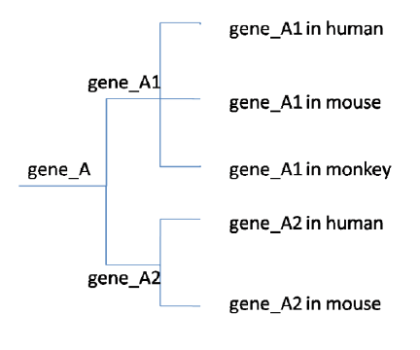

  - paralog: gene_A1 and gene_A2, gene_A1 in human and gene_A1 in human, gene_A1 in mouse and gene_A2 in mouse
  - ortholog: gene_A1 in human and gene_A1 in mouse and gene_A1 in monkey, gene_A2 in human and gene_A2 in mouse

- What are the biological and computation heuristics (“tricks”) that Blast uses? Describes each of them briefly! (8)
  - computational heuristics: a) exact matching is fast, b) search space can be easily reduced
  - biological heuristics: a) local similarities are dense, b) similar regions are near each other, c) low complexity sequences excluded, etc.

  - (majd kesobb)

- What are the non-annotated sequence clusters? How can you use them to find a function of an unknown protein sequence? (4)
  - Non-annotated clusters, such as Uniref, are automatically maintained, sometimes heterogeneous
  - Searched as part of a standard sequence database. (Uniprot)
  - Searches need to be checked manually.
  - first - using BLAST to find a function of an unknown protein sequence
    - strong similarity to a protein with known function or
    - no similarity to proteins with different function. this is called an unequivocal similarity.
  - second - using Cluster resources for sequence classification
    - if you have an unannotated protein an unannotated protein as the best hit in a similarity search:
      - Go to Uniref 90%, and see if the protein is member of a cluster that has annotated members. Decide if the annotation can be accepted.
      - Go to ProgMap that locates your most similar protein in all known clusters and comes up with plausible annotation.

- Define the following terms (3):
  - read: A single piece of output by a sequencer(typically a 50-500bp long DNA sequence).

  - coverage: The number of times a (genome) sequence is covered with reads. Sequence coverage is the fraction of the genome covered by reads.

  - scaffold: One or more contigs linked together by unknown sequence segments

- What is whole genome sequencing and targeted sequencing? Give an example (clinical/scientific) hen we can use them! (4)
  - targeted sequencing: re-sequencing parts of known genomes, such as for disease diagnosis (human).
  - whole genome sequencing: collecting read sequences, assembling them by themselves or with the help of a known genome, prediction of genes, mutations

- What is the difference between the following terms: SNP, mutation? (2)

Mutáció | SNP
5-10/ember | 18 millió mindenkiben
populáció <1%-ban | populáció >1%-ban
bárhol lehet a genomban | meghatározott helyeken lehet
bármelyik nukleotid-változás | kétfajta bázis valamelyike
okozhatja a kódlt fehérje működését | lehet csendes polimorfizmus, mely még az aminosavat sem változtatjameg
de okozhatja csak egy aminosav változását is | és lehet olyan, amely egy aminosavat változtat meg

- What are the three methods of DNA fragmentation?
  - Physical fragmentation
    - acoustic shearing
    - sonication
  - Enzymatic method
    - DNase l or other restriction endonuclease
  - Chemical fragmentation
    - heat digestion with a divalent metal cation (magnesium or zinc)

- Given the reads {ACTT, TGCT, GCTT, TTTG, TTGC, CTTG, CTTT}. What is the original sequence? Use the de Bruijn graph based algorithm for the computation! (6)
A C T T
C T T T
T T T G
T T G C
T G C T
G C T T
C T T G
Original sequence: ACTTGCTTG

