- What is the convergence in the field of information and communication technology? What are the consequences?
Convergence in networks:
- Traditionally separate networks and different technologies for telephone, for cable TV, for radio program broadcasting, for data communications
- Today: we make telephone calls on CaTV networks, on Internet, we access the Internet via telephone lines (ADSL) or using Mobil telephone networks.
Convergence in terminals:
Traditionally it was telephone, TV set, computer, CD player……
Today: we play MP3 files on mobile telephone, watch TV programs on Computer, edit excel files on mobile phone, read e-mails on TV screen….

- Which fields of technologies develop faster? What are the consequences?
Gilder’s law on bandwidth:The total bandwidth tripling within 12 months.
Infinite bandwidth: 10Gbit/s per carrier, 1000 carrier per fibre, 1000 fibre per cable-> totally 10^16 bit/s/cable -> 1 optical cable is suitatble to download 4 persons full life within 1 second (human life ~ 80 years = 2.5*10^9 s)
Free bandwidth: PPKE has connection to the NIIF network by 2 Gb/s link. The leasing fee for the dark fibre takes about 200.000 Ft/month. Downloading 1Gb takes in the ITK = 0,079 Ft!!!
Consequence: Free(??) products are nod good basis of business ! Only way to have profit to force wasteful usage or to pay for other products. New network philosophy, structure, new functions in the nodes.Completely different user behaviour. New ratio of computing – downloading – storing!

- Which kind of limits are in the field of electronic communications?
- What are the main transmission characteristics of twisted pair cables (Attenuation, characteristic impedance, crosstalk…)? What are the main applications of twisted pair cables?
Twisted pair cable: Twisted pair cabling is a type of wiring in which two conductors of a single circuit are twisted together for the purposes of canceling out electromagnetic interference (EMI) from external sources.
Attennuation: Reduction in the strength of a signal. Unit: [dB]
Characteristic impedance: Z0.The characteristic impedance of a transmission line is the ratio of the voltage and current of a wave travelling along the line.
NeXT: Near-end Crosstalk. Interference between two pairs in a cable is measured at the same end of the cable as the interfering transmitter.
FeXT: Interference between two pairs of a cable measured at the other end of the cable with respect to the interfering transmitter.
Main applications of twisted pair cable: Ethernet cabling (UTP).

- What are the main characteristics of coaxial cables? What are the main applications of coaxial cables?
Coaxial cable: is a type of cable that has an inner conductor surrounded by a tubular insulating layer, surrounded by a tubular conducting shield.
Characteristics: Characteristic impedance, attenuation, velocity of propagation ( the ratio of the speed at which a wavefront passes through the medium, to the speed of light in a vacuum), Peak Voltage (The peak voltage is set by the breakdown voltage of the insulator).
Main applications: Coax cable is often used to carry data/signals from an antenna to a receiver—from a satellite dish to a satellite receiver, from a television antenna to a television receiver, from a radio mast to a radio receiver, etc. Short coaxial cables are commonly used to connect home video equipment, in ham radio setups, and in measurement electronics. Long distance coaxial cable was used in the 20th century to connect radio networks, television networks, and Long Distance telephone networks.

- What are the main transmission characteristics and propagation modes of fiber cables? What are the main applications of fiber cables?

- What are the main transmission characteristics of radio connections? What is the fading?
Transmission characteristics:
- path loss: Path loss (or path attenuation) is the reduction in power density (attenuation) of an electromagnetic wave as it propagates through space.
- delay: The time difference in propagation (called propagation delay) between two signals which had taken different paths may interfere with reception, since the data streams that are received overlap with one another.
- fading: In wireless communications, fading is deviation of the attenuation affecting a signal over certain propagation media. In wireless systems, fading may either be due to multipath propagation, referred to as multipath induced fading, or due to shadowing from obstacles affecting the wave propagation, sometimes referred to as shadow fading.
- reflection: When a radio wave hits an obstacle, some or all of the wave is reflected, with a loss of intensity. Reflection is such that the angle of incidence is equal to the angle of reflection.
- polarization: Property of a radiated electromagnetic wave describing the time varying direction and relative magnitude of the electric-field vector. In general, the field is elliptically polarized.
- Which frequency bands are used in radio communications? What are the main wave propagation modes?
Used frequency bands:
- LF (30-300kHz)
- MF (300-3000kHz)
- HF (3-30 MHz)
- VHF (30-300 MHz)
- UHF (300-3000MHz)
- SHF (centimetric waves, 3-30GHz)
- EHF (millimetric waves, 30-300GHz)
Propagation modes:
- Ground wave propagation (below 2 MHz)
- Sky wave propagation (2 to 30 MHz)
- Line-of-Sight propagation (above 30 MHz)
- What are the Characteristics and main application of terrestrial and space radio communications?
Characteristics:
- Principles of cellular systems:
In the cellular concept, frequencies allocated to the service are re-used in a regular pattern of areas, called 'cells', each covered by one base station. In mobile-telephone nets these cells are usually hexagonal. In radio broadcasting, a similar concept has been developed based on rhombic cells.
in a cluster each cell has a separate frequency
'a' is the area of one cell
'A' is the cluster area
'R' is the cell diameter
'D' is the distance between clusters (the distance between cells with identical frequencies
'K' is the number of the cluster cells
K=A/a=(D/(sqrt(3)*R))^2
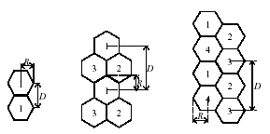
- Which frequency bands are used in satellite communications? What are the main communications problems in satellite communications?
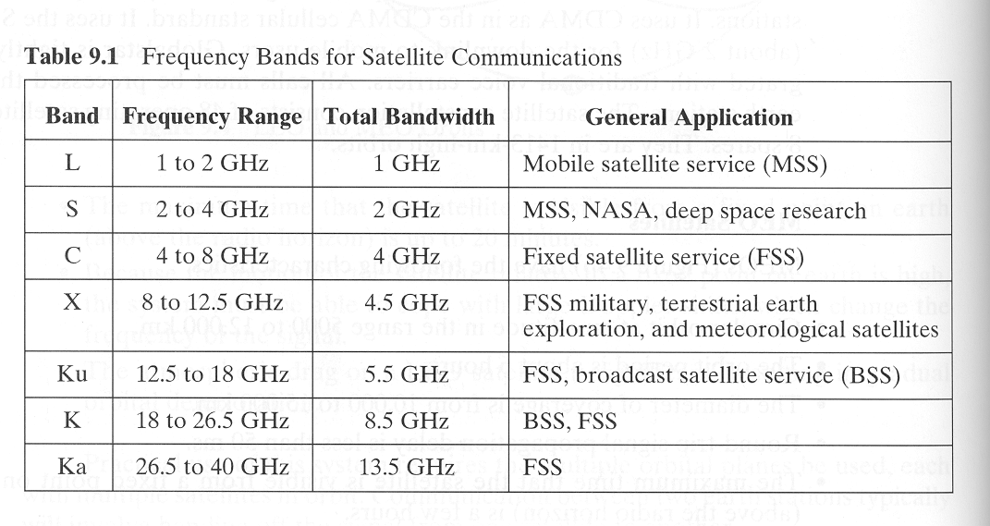
- Analog modulation systems (AM-FM)
AM: Amplitude Modultaion. The momentary amplitude of the carrier is proportional to the momentary amplitude of the modulating signal.
FM: Frequency Modulation. The momentary frequency of the carrier is proportional to the momentary amplitude of the modulating signal.
- Digital modulation systems (BPSK., QPSK, QAM)
Phase-Shift Keying: Phase-shift keying (PSK) is a digital modulation scheme that conveys data by changing, or modulating, the phase of a referencesignal (the carrier wave).
BPSK: Binary Phase-Shift Keying. BPSK is the simplest form of phase shift keying. It uses two phases which are separated by 180°. It does not particularly matter exactly where the constellation points are positioned. This modulation is the most robust of all the PSKs since it takes the highest level of noise or distortion to make the demodulator reach an incorrect decision. It is, however, only able to modulate at 1 bit/symbol and so is unsuitable for high data-rate applications.
QPSK: Quadrature Phase-Shift Keying. QPSK uses four points on the constellation diagram, equispaced around a circle. With four phases, QPSK can encode two bits per symbol to minimize the bit error rate. The mathematical analysis shows that QPSK can be used either to double the data rate compared with a BPSK system while maintaining the same bandwidth of the signal, or to maintain the data-rate of BPSK but halving the bandwidth needed. In this latter case, the BER of QPSK is exactly the same as the BER of BPSK - and deciding differently is a common confusion when considering or describing QPSK. The transmitted carrier can undergo numbers of phase changes.
QAM: Quadrature amplitude modulation is both an analog and a digital modulation scheme. It conveys two analog message signals, or two digital bit streams, by changing (modulating) the amplitudes of two carrier waves, using the amplitude-shift keying (ASK) digital modulation scheme or amplitude modulation (AM) analog modulation scheme.
- What are the main functions of multiplexing and switching nodes in the networks?
- To reduce transmission costs
- To utilize higher bandwidth
- Framing and packing of information
- What are the main elements and characteristics of PDH systems?
- What are the main elements and characteristics of SDH systems?
SDH: Synchronous Digital Hierarchy. Synchronous Digital Hierarchy (SDH) is a standardized protocol that transfers multiple digital bit streams synchronously over optical fiber using lasers or highly coherent light from light-emitting diodes (LEDs).
Main elements:
- VC: Virtual Container (multiplexing level)
- STM-N: Synchronous Transport Modules (line signal level)
- POH: Path-Overhead (control and supervisory information)
- POH + Payload = VC
- A number of VC-s can be packaged into a larger VC.
Transport modules:
- RSOH – Regenerator Section Overhead
- MSOH – Multiplexer Section Overhead
- AU Pointer – Administrative Unit Pointer
- Duration of STM-1 module is 125 us
- What are the main elements and characteristics of ATM systems?
ATM: Asynchronous Transfer Mode (ATM) is, according to the ATM Forum, "a telecommunications concept defined by ANSI and ITU (formerly CCITT) standards for carriage of a complete range of user traffic, including voice, data, and video signals".
Principle: Fixed cell (packet) length – 53 bytes
5 octets header, 48 octet payload
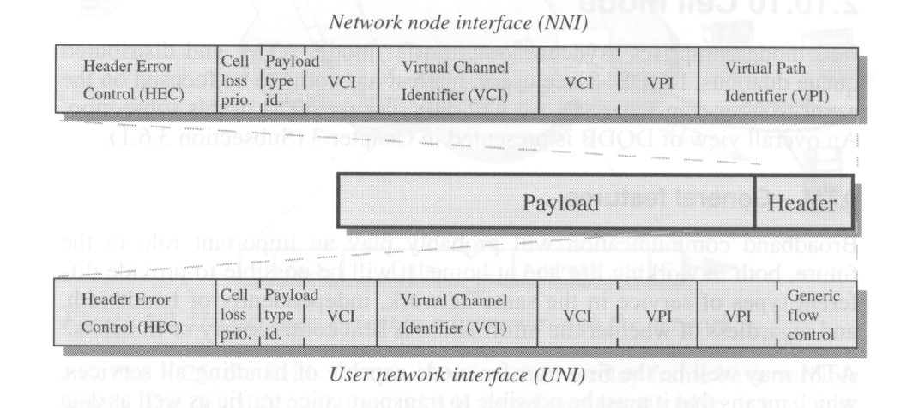
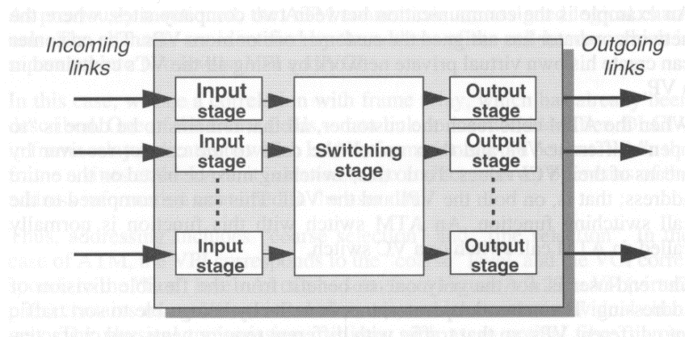
- What are the elements of time and space switches?
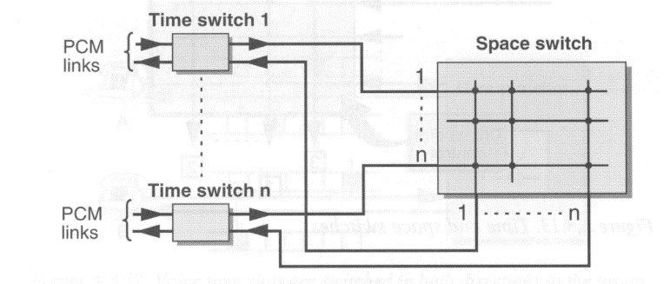
- What are the main features of circuit switching, packet switching and cell switching?
Circuit switching: Circuit switching is a methodology of implementing a telecommunications network in which two network nodes establish a dedicated communications channel (circuit) through the network before the nodes may communicate. The circuit guarantees the full bandwidth of the channel and remains connected for the duration of the communication session. The circuit functions as if the nodes were physically connected as with an electrical circuit.
Packet switching: Packet switching is a digital networking communications method that groups all transmitted data into suitably sized blocks, called packets, which are transmitted via a medium that may be shared by multiple simultaneous communication sessions. Packet switching increases network efficiency, robustness and enables technological convergence of many applications operating on the same network.
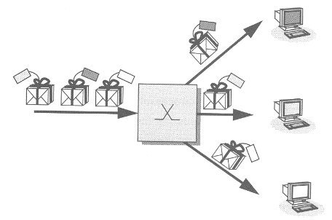
Cell switching: ATM.
- Spread spectrum, FHSS, DSSS
Spread spectrum: In telecommunication and radio communication, spread-spectrum techniques are methods by which a signal (e.g. an electrical, electromagnetic, or acoustic signal) generated with a particular bandwidth is deliberately spread in the frequency domain, resulting in a signal with a wider bandwidth. These techniques are used for a variety of reasons, including the establishment of secure communications, increasing resistance to natural interference, noise and jamming, to prevent detection, and to limit power flux density (e.g. in satellite downlinks).
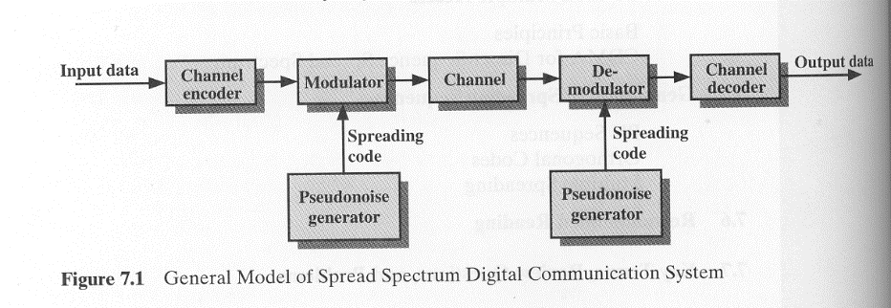
FHSS: Frequency Hoping Spread Spectrum. A number of channels are allocated for FH.
The transmitter operates in one channel at a time for fixed Code Time interval (Tc)
During that interval, some number of bits or a fraction of a bit are transmitted (signal elements)
The time interval of signal (Symbol Elements) Ts.
The sequence of the channels used is dictated by spreading code.
Both transmitter and receiver use the same code to tune into a sequence of channels in synchronisation.
DSSS: Direct Sequence Spread Spectrum. Direct-sequence spread-spectrum transmissions multiply the data being transmitted by a "noise" signal. This noise signal is a pseudorandom sequence of 1 and -1 values, at a frequency much higher than that of the original signal. The resulting signal resembles white noise, like an audio recording of "static". However, this noise-like signal is used to exactly reconstruct the original data at the receiving end, by multiplying it by the same pseudorandom sequence (because 1 × 1 = 1, and −1 × −1 = 1).
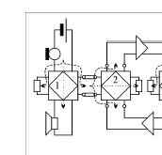
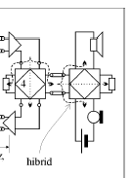
- What are features of 2 wire and 4 wire connections?
Used for voice, video communication, etc.
2-wire: 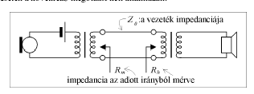
4-wire:
- What is the network structure of the MATÁV network?
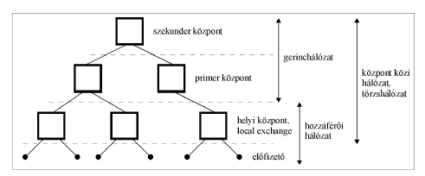
- What is the network structure of the PANTEL network?
- What are the main components of a GSM network?
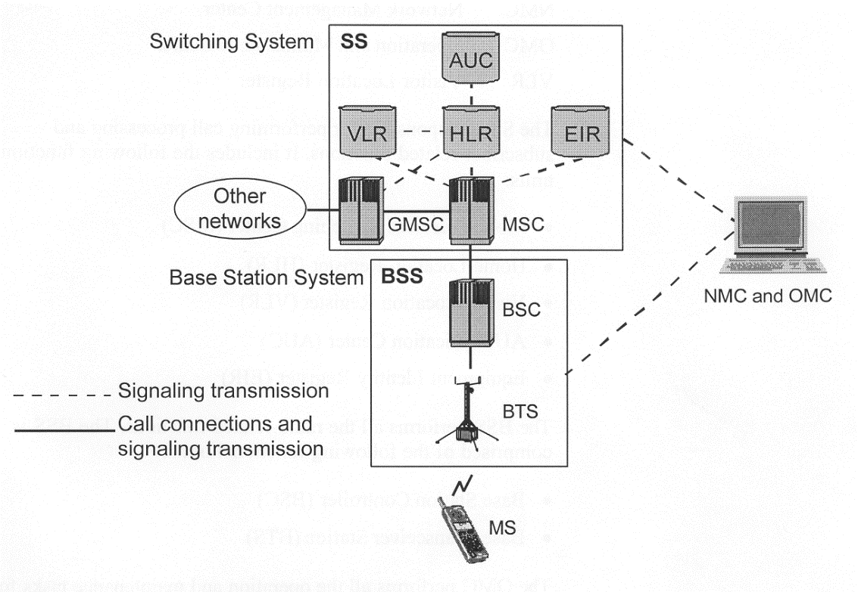
- What are the operating statuses of a MS?
MS: Mobile Station. Used by mobile subscriber to communicate with the network
Consist of mobile terminal and Subscriber Identity Module (SIM)
Subscription is separated from the mobile terminal
Subscription information is stored in a „smart card”
Hand-held MS, Car-installed MS
MS operating statuses
- Idle: the MS is ON but a call is not in progress.
- Active: The MS is ON and a call is in progress
- Detached: The MS is OFF
Key terms for Idle state:
- Registration: MS informs a network that it is attached
- Roaming: MS moves around the network in idle mode
- International Roaming: MS moves into a network which is not its home network.
- Location Updating: MS inform the network when enters in new LA
- Locating: BSC function to suggest connection to another cell based on MS measurement reports
- Paging: The network tries to contact an MS by broadcasting message containing MS identity
Key terms for active state:
- Handover: Handover: Process, where a call is switched from one physical channel to another, while MS moves around
- What are the actions of the network during roaming and handover?
Roaming: The idle MS moves thorough the network,
- scan the control channels,
- tune to the strongest channel,
- in new LA (Location Area) inform the network of its new location
Handover:
1. BSC send handover-required message to the MSC
2. The MSC ask the target MSC to assist. The Target MSC allocates a handover number that reroutes the call.
3. A handover request is sent down to the new BSC
4. The BSC tells the new BTS to activate a TCH
5. The MSC receives the information about the new Traffic Channel
6. The MSC passes info on new TCH from new BSC
7. A speech path to the new MSC is set up.
8. A handover command goes to the MS with frequency and time slot data in the new cell.
9. The MS sends handover burst on the new TCH
10. The target MSC is informed that the handover successful
11. A new path in the Group Switch is set up.
- What are the functions of HLR and VLR in the GSM network?
HLR: Home Location Register. Centralized network database for
- Subscriber identity
- Subscriber supplementary services
- Subscriber location information
- Subscriber authentication information
VLR: Visitor Location Register. Information about subscribers located in an MSC service area (a copy of HLR information)
- What are the functions of MSC and BSC in the GSM network?
Base Station Controller (BSC):
- Manages all the radio related functions of the network
- MS handover
- Radio channel assignment
- collection of cell configuration data
- Controlled by MSC
Mobile Switching Center (MSC):
- The mobile switching center (MSC) is the primary service delivery node for GSM/CDMA, responsible for routing voice calls and SMS as well as other services (such as conference calls, FAX and circuit switched data). The MSC sets up and releases the end-to-end connection, handles mobility and hand-over requirements during the call and takes care of charging and real time pre-paid account monitoring.
- What are the steps to call MS?
1. Call entering to GSM network is routed to the nearest GMSC
2. The GSM analyse the MSISDN to find the HLR (subscriber registered in) The MSC/VLR address is stored in HLR, the IMSI is stored in HLR
3. The HLR send request to an MSRN to the MSC/VLR included in the message the IMSI
4. The MSRN is returned via HLR to the GMSC
5. The GMSC routes the call to the MSC/VLR by MSRN
6. The MSC/VLR retrieve the Ms’s IMSI
7. Using IMSI MSC identifies LA
8. The MS is paged in cells in the LA
9. MS responds, authentication, cipher mode setting, IMEI check are carried out
10. Traffic channel connected from MSC to BSC and the BTS
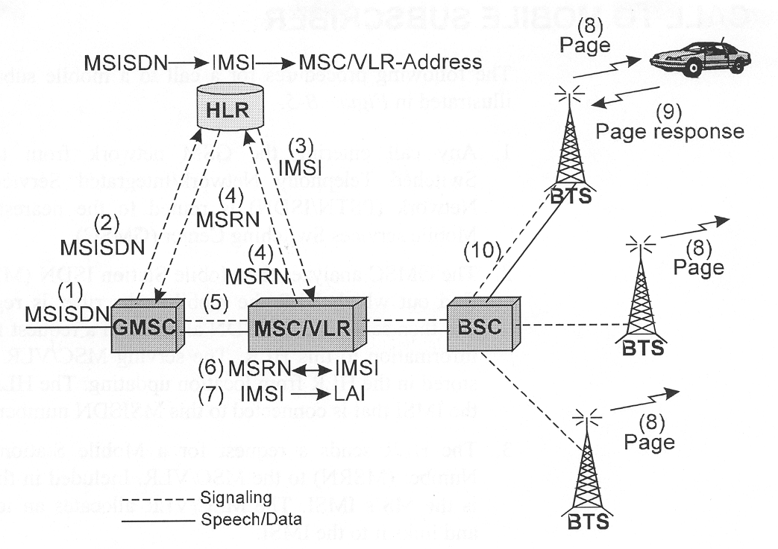
- What are the steps call from MS?
1. Call start with a signalling channel using RACH (Random Access Channel)
2. MS indicates request, IMSI is analysed, MS marked busy in The VLR
3. Authentication is performed by MSC
4. Ciphering is initiated, IMEI validated
5. MSC receives a setup message from MS (including B number)
6. Link established between MSC and BSC to assign traffic channel
7. Call confirmation
8. Call accepted
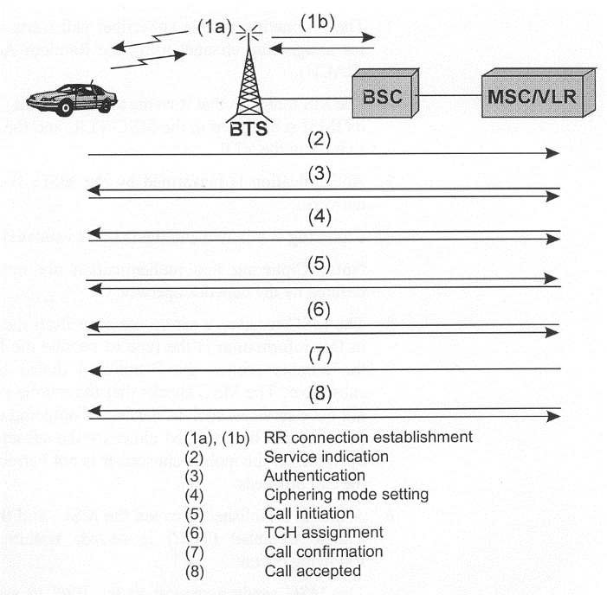
- Which services are supported in GSM system and how?
- What is the function of a private network?
Closed User Group, Special Purpose network.
Common features of private networks:
- Internal numbering schemes, addressing system
- Strictly regulated gateway function for interconnection to other (public) networks
- The transmission part of networks might be leased line or own connection (radio)
- The multiplexing, switching, management, authentication processes are private functions
- Task oriented service quality parameters (reliability, usability, error rate, response time, redundancy, backup time …)
- Separated frequency management („governmental” use)
- What are the function and structure of a CATV network?
- Traditional AM VSB TV sets,
- Set top boxes for receiving DVB programs (including demodulator, MPEG decoder and some sort of descramblers)
- Internal frequency plan with 8 MHz raster (free assignment of programs to 8 MHz channels)
- Low split system: from 5 MHz up to 55 (50, 68) MHz for the uplink path, from 70 (87) MHz up to 630 MHz for the analogue downlink path and 630-862MHz for digital downlink path,
- 8 TV and 8 radio channel in one 8 MHz channel (in the digital channels)
the nominal impedance at all connection points of CATV system is 75 ohms
- MPEG-2 principles
- Intra-coding relies on two characteristics of typical images. First, not all spatial frequencies are simultaneously present, and second, the higher the spatial frequency, the lower the amplitude is likely to be. Intra-coding requires analysis of the spatial frequencies in an image.
- Inter-coding relies on finding similarities between successive pictures. The next picture can be created by sending only the picture differences. The shifting process is controlled by a pair of horizontal and vertical displacement values (collectively known as the motion vector) that is transmitted to the decoder. The motion vector transmission requires less data than sending the picture-difference data.
- What is the MPEG stream and transport stream?
MPEG stream: An elementary stream is an endless near real-time signal.
Program streams have variable-length packets with headers.
Transport stream: In a transport stream the PES packets are further subdivided into short fixed-size packets and multiple programs can be carried in the same stream.
- What is the structure of the HUNGARNET network? Why?
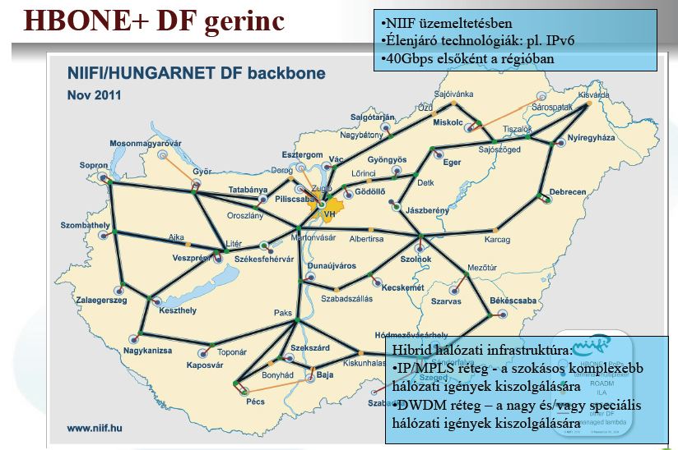
- Which technologies and structures are applied in the networks of ITK building?

